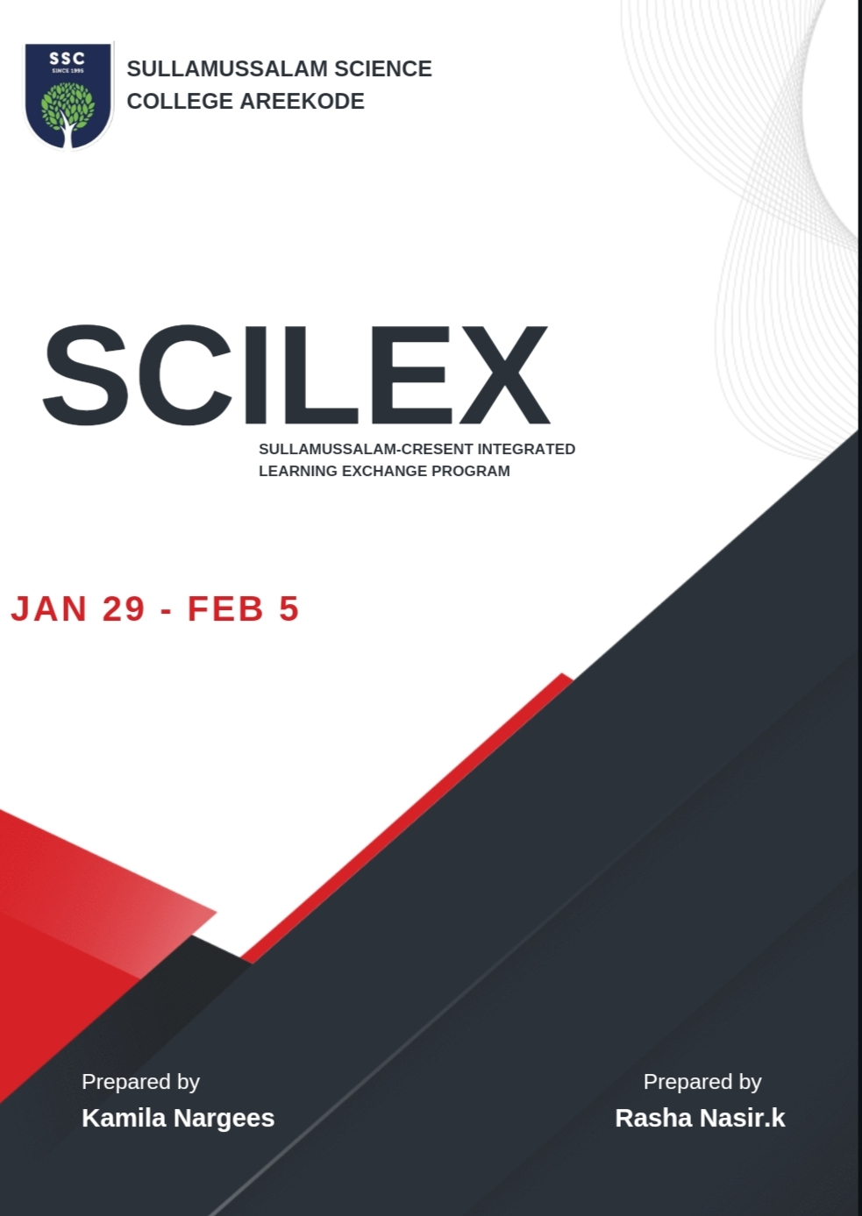

Report on Sullamussalam-Crescent Integrated Learning Exchange Programme (SCILEX) 2024 at BS Abdur Rahman Crescent Institute of Science and Technology, Chennai

The Sullamussalam-Crescent Integrated Learning Exchange Programme (SCILEX) 2024 at BS Abdur Rahman Crescent Institute of Science and Technology in Chennai commenced on January 29, 2024. This program aimed to provide an enriching and delightful learning experience for participating students and faculty members.

The program included 16 students representing various disciplines and 2 faculty members from Sullamussalam Science College, Areekode to BS Abdur Rahman Crescent Institute of Science and Technology. This diverse group of participants contributed to a rich exchange of ideas and perspectives throughout the program.

The journey began at Kozhikode Railway Station, marking the start of an exciting adventure in learning and collaboration. The departure on January 29, 2024, symbolized the beginning of a journey filled with opportunities for growth and exploration.

**Enriching Learning Experience:**

SCILEX 2024 aimed to offer a comprehensive learning experience, blending theoretical knowledge with practical applications to foster holistic development among participants.

**Thankyou Note**

The college community extends its sincere gratitude to the management, principal, and faculty members for facilitating the cultural student exchange program with BA Crescent Institute of Science and Technology, Chennai. This program provided students with invaluable cultural insights, broadened their academic perspectives, and enabled them to form meaningful connections with their peers in Chennai, significantly contributing to their personal and professional growth. The dedication and support of the college leadership in making this enriching experience possible are deeply appreciated.

**Outcomes:**

The SCILEX 2024 program has thus far achieved the following outcomes:

**Enhanced Interdisciplinary Understanding:**

Through interactions with peers from diverse disciplines, participants gained a deeper understanding of interdisciplinary perspectives and approaches.

**Skill Development:**

Engaging in various activities and sessions, participants honed their skills in communication, critical thinking, problem-solving, and teamwork.

**Cultural Exchange:**

The program provided opportunities for cultural exchange, allowing participants to learn from each other’s backgrounds, traditions, and experiences.

**Networking Opportunities :**

Participants had the chance to network with industry experts, students, and other professionals, expanding their professional connections and opportunities.

# **DAY 1**

## **Inaugration**

On 30 January 2024, the Sullamussalam-Crescent Integrated Learning Exchange Programme, ‘SCILEX,’ commenced, emphasizing the importance of cultural exchange in discovering the humanity that unites us, transcending borders and differences.

The Executive Committee of B.S. Abdur Rahman Crescent Institute of Science & Technology, along with faculties and students of Sullamussalam Science College, Areekode, gathered at the Seminar Hall for the official inauguration. At 10:00 sharp, the program commenced with a Qiraath by Dr. Sibaghatullah Nasir, Assistant Professor, Department of Commerce, in the presence of all administrative board members, faculties, and students. The program was welcomed by Dr. Ayub Khan Dawood, Professor and Dean, School of Social Sciences and Humanities, and presided over by Prof. Dr. T. Murugesan, Vice-Chancellor, BSACIST.

The inaugural session was officially commenced by Dr. N. Thajuddin, Pro-Vice-Chancellor, BSACIST. Dr. N. Raja Hussain, Registrar, BSACIST, Dr. V. Murugesan, Advisor, BSACIST, and Dr. P. S Syed Masood Jamali felicitated the session. Students from Sullamussalam Science College introduced themselves, followed by a university video presentation. Dr. K. Soundarapandiyan, Associate Professor and Head, Department of Commerce rendered the vote of thanks.

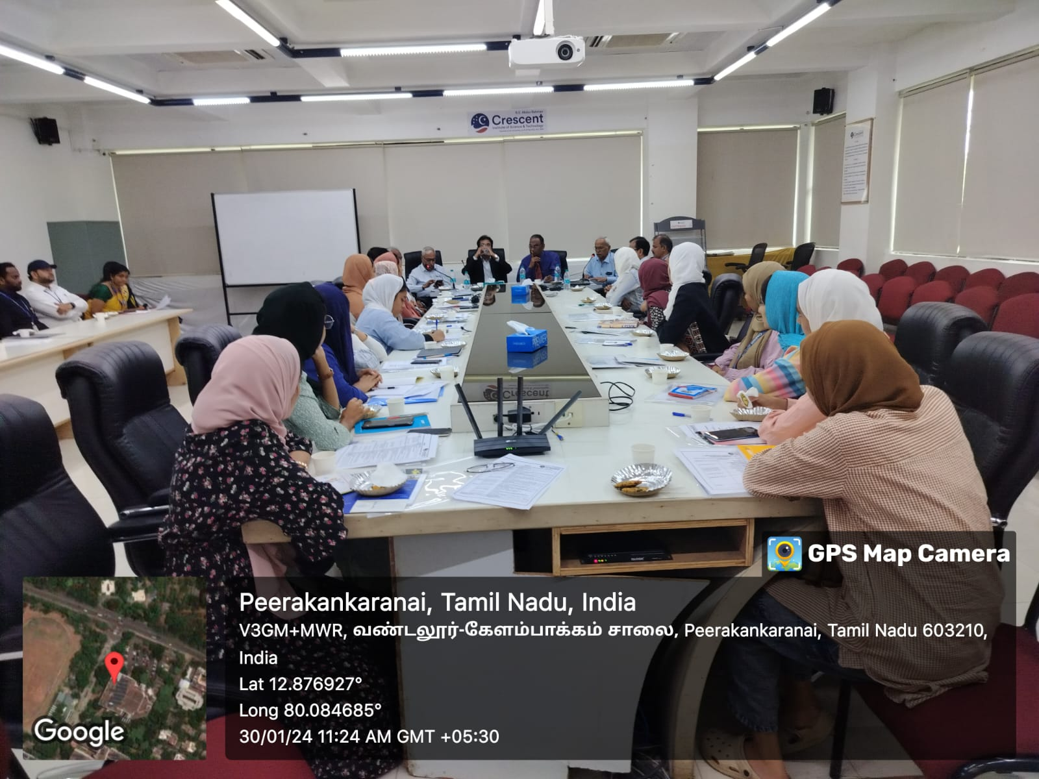

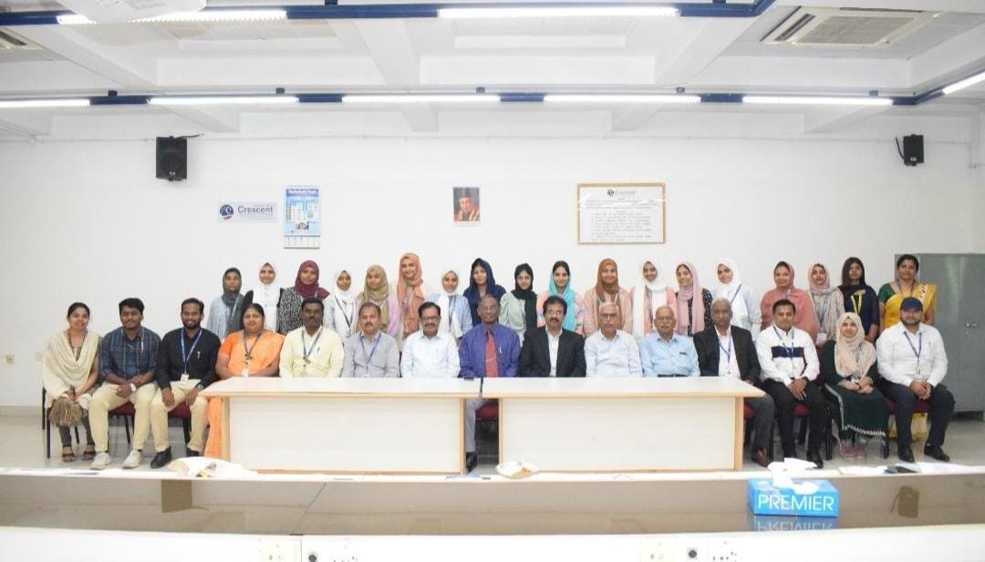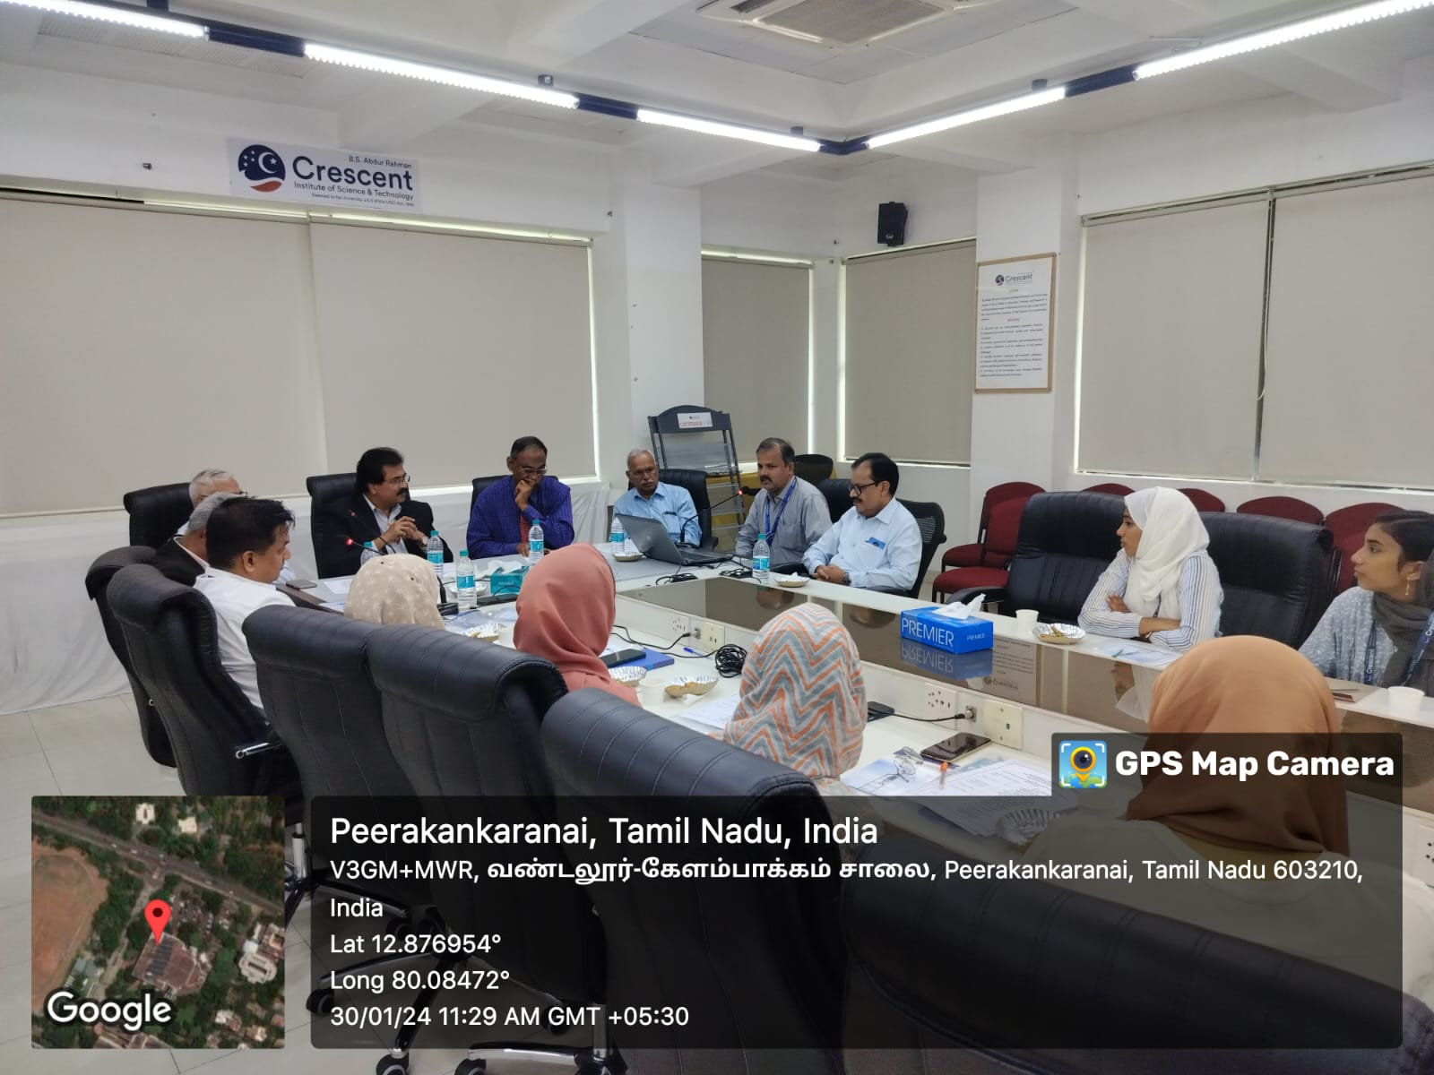

•Time-11:15am-01.00 pm

Afterward, the students toured various facilities within BSACIST such as the Administrative Block, Central Library, and different departments.

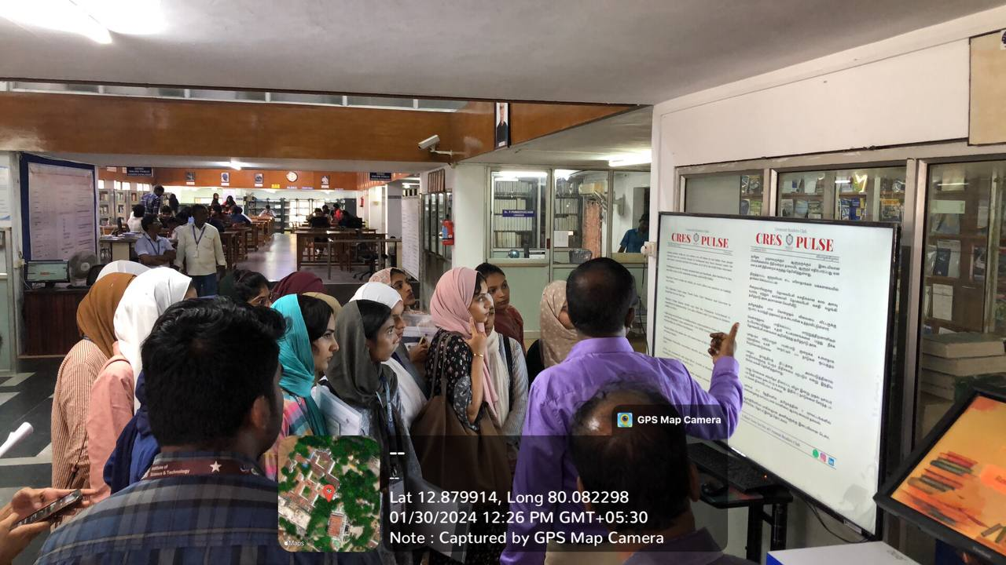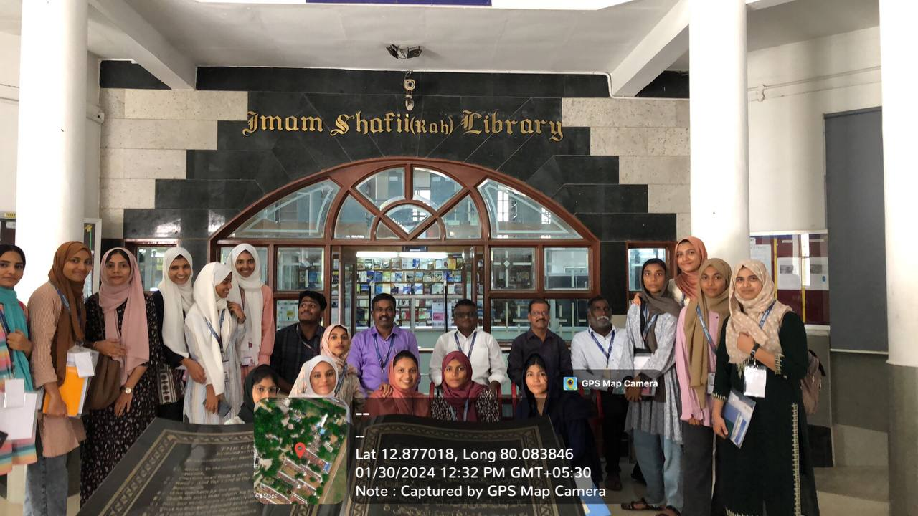

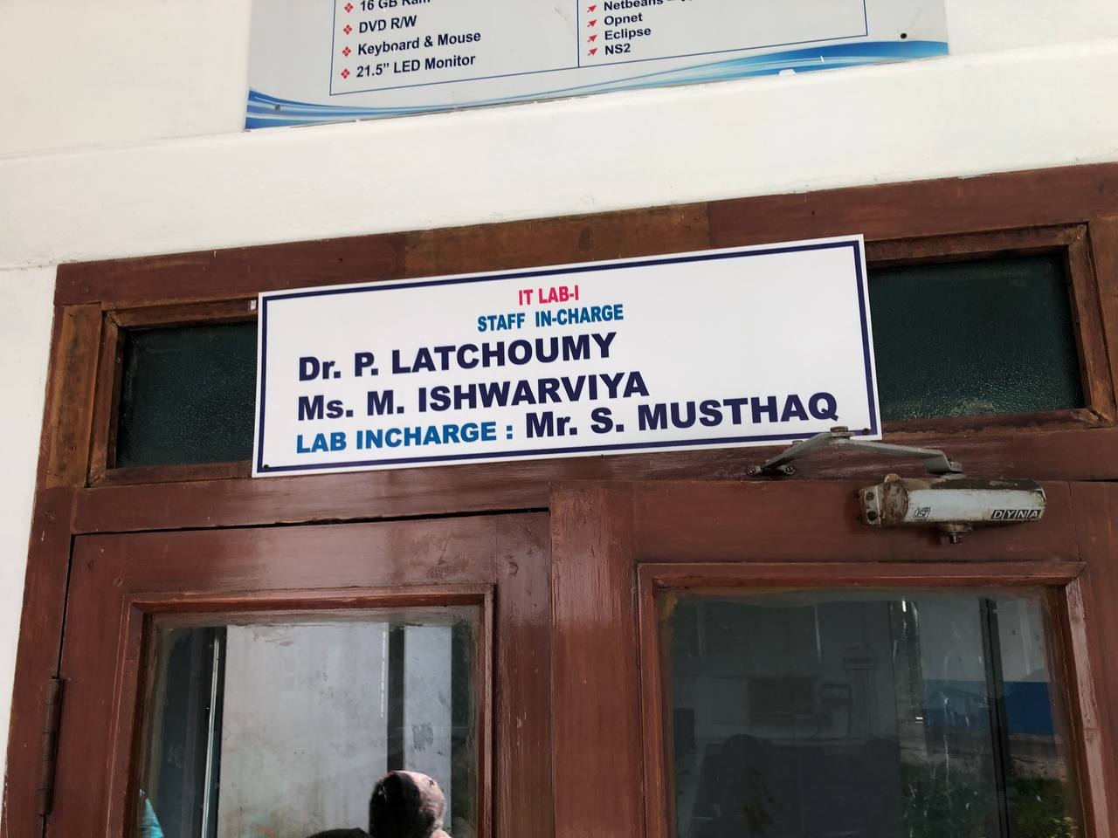

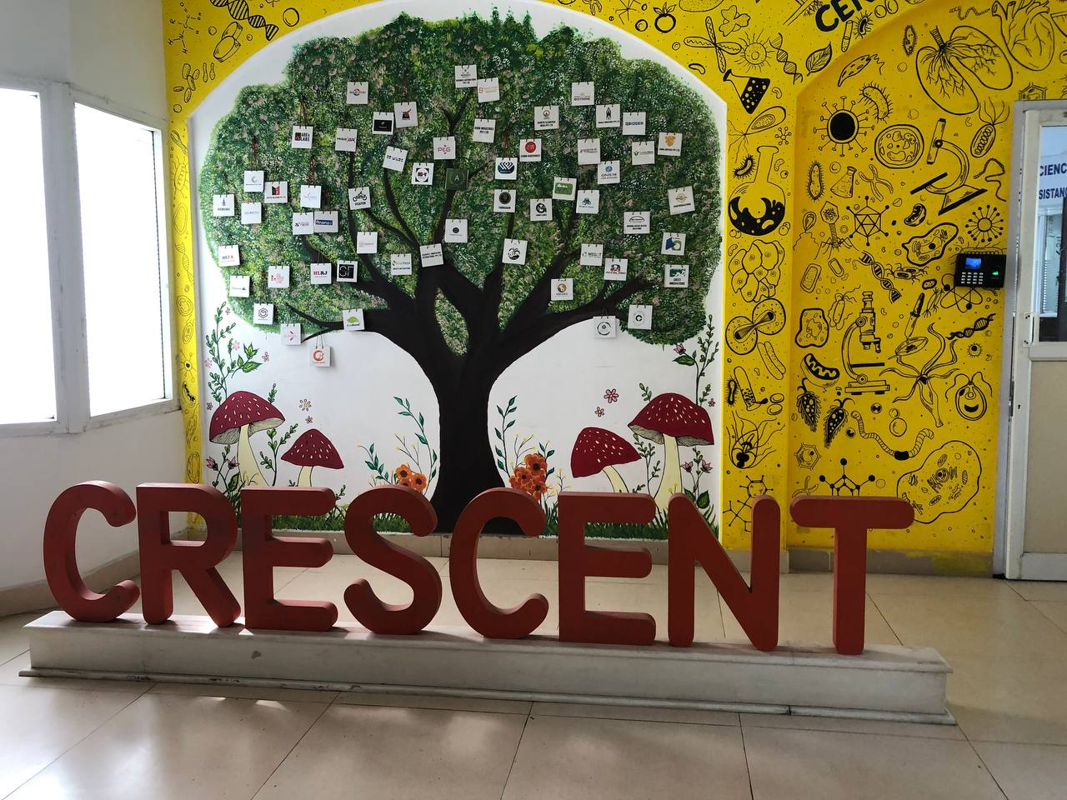

• Time-01.00pm-02.00pm

(Lunch Break)

•Time-02.00pm-04.00pm

• Visit to CIIC(Cresent Innovation &Incubation Council

# **Session -1**

Topic

**Women Entrepreneurship and Start-up in India**

Resource person

Dr. Nisha Mukund, CEO, Crescent Innovation & Incubation Council (CIIC)

The session on women entrepreneurship within the Start-Up India framework provided a comprehensive exploration of the challenges, opportunities, and support mechanisms for women entrepreneurs in India. It aimed to empower women economically, foster inclusivity, and contribute to the growth of the startup ecosystem.

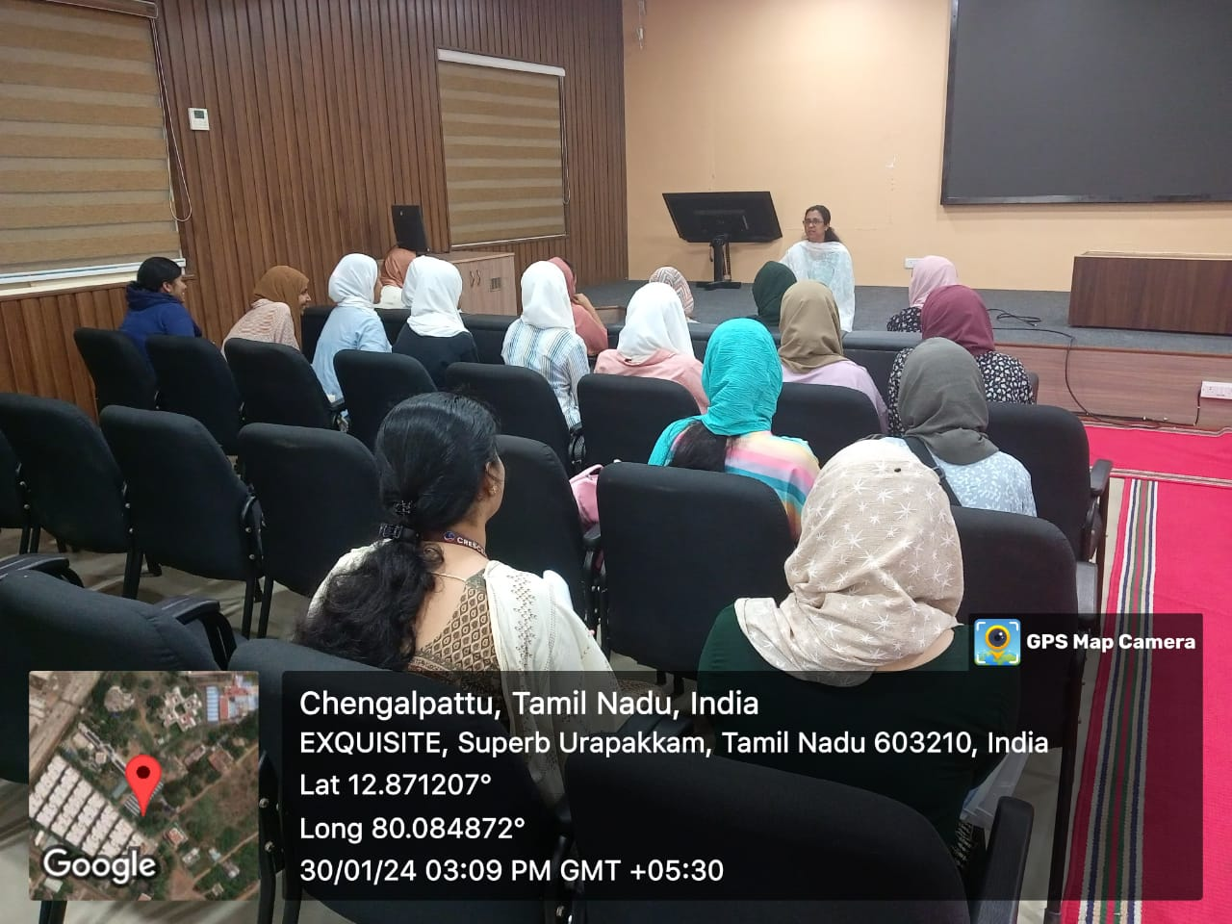Continued efforts to build on the momentum generated by this session will be essential to ensuring the long-term success and sustainability of women-led startups in India.

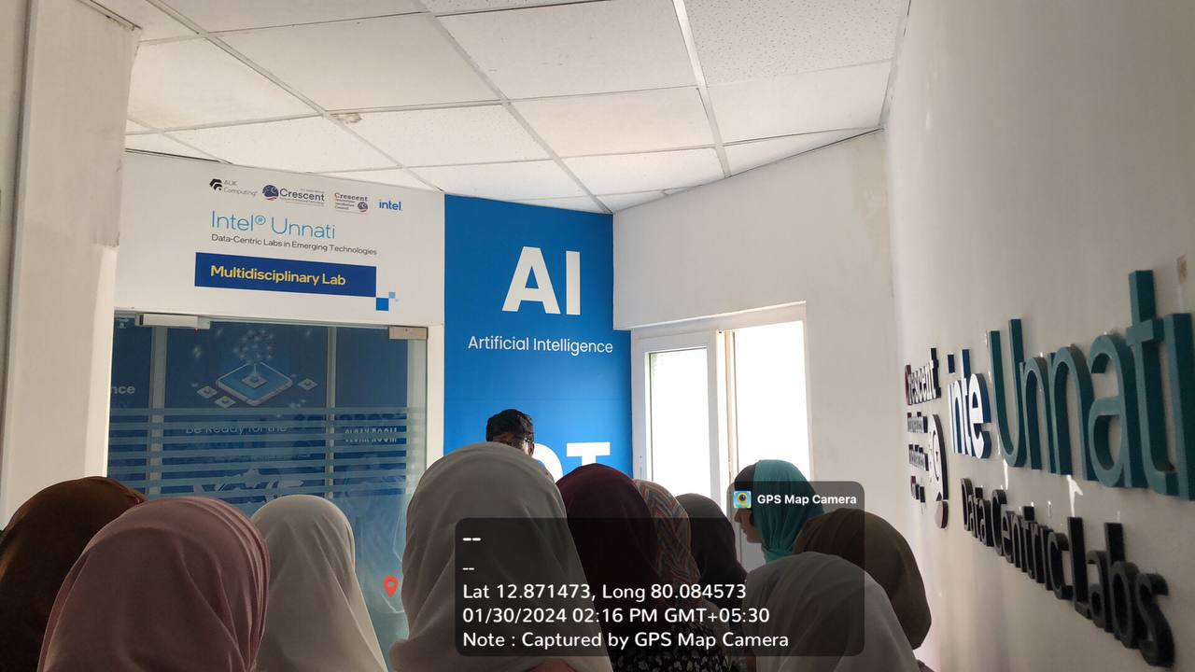

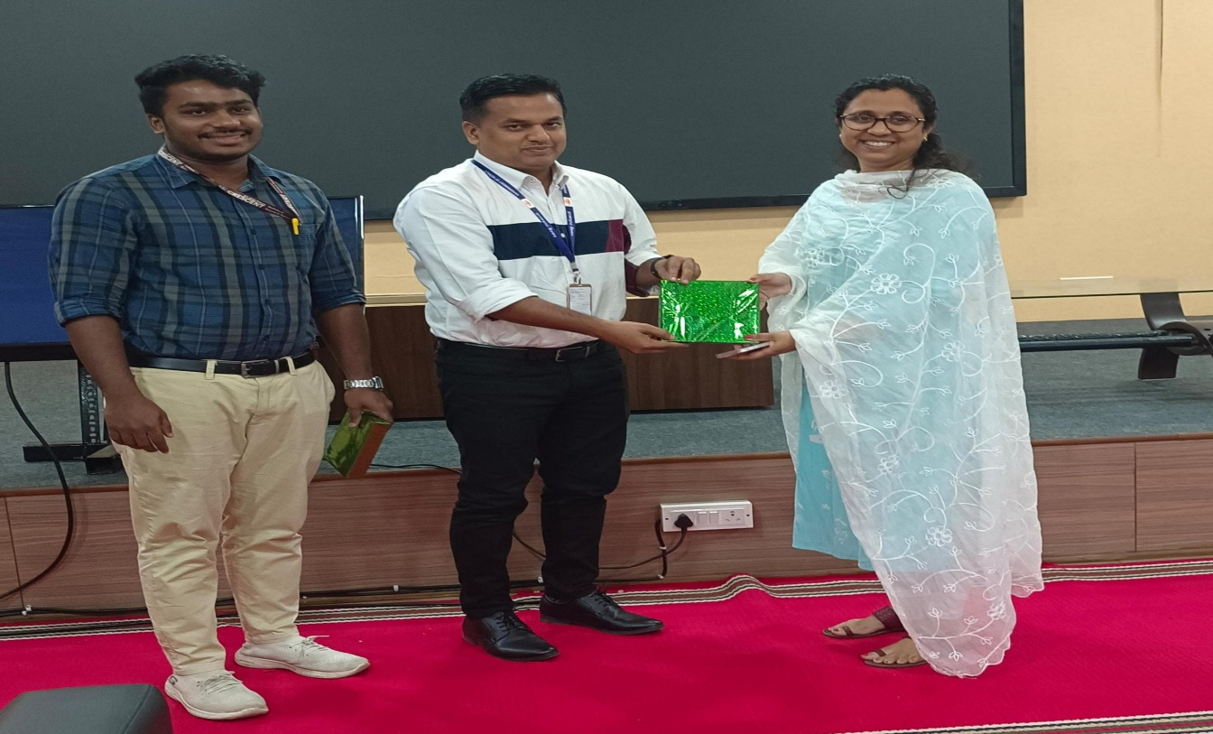

•Time:05.00 pm -06.00pm

**Physical Education**

By Dr. Selvakumar, Director, Physical Education, BSACIST_Kk

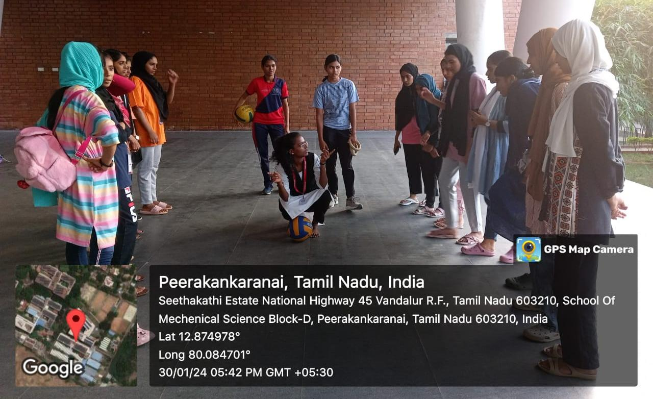

# **Day 2**

31/01/2024

The art of communication is the language of leadership

The second day of SCILEX commenced with renewed energy after a good night’s sleep. All participants gathered in the courtyard of the administrative block. We then proceeded to the Architecture department with our coordinators for the first session of the day.

# **Session 2**

Time:10:00

Topic

**Communication Skills**

Resource person

_Dr. S. Vjayakumar_

( _Associate Professor, Department of English, BSACIST)_

The initial lecture of the day began with an inspiring quote: “Great leaders communicate; great communicators lead.” Dr. Vjayakumar elaborated on the four skills of communication in a unique and engaging manner, making it a truly uplifting session.

He kickstarted the session with an energy-boosting mathematical game, and everyone participated enthusiastically. Aza Anjum excelled in the game, securing the first place. The lecture encompassed the nuances of verbal and non-verbal communication, incorporating practical sessions with students. As a gesture of gratitude, at the end of the session, we presented token of appreciation to Dr. S. Vjayakumar, our esteemed faculty.It marked a fantastic start to the day, and we dedicated our full attention to this informative session.

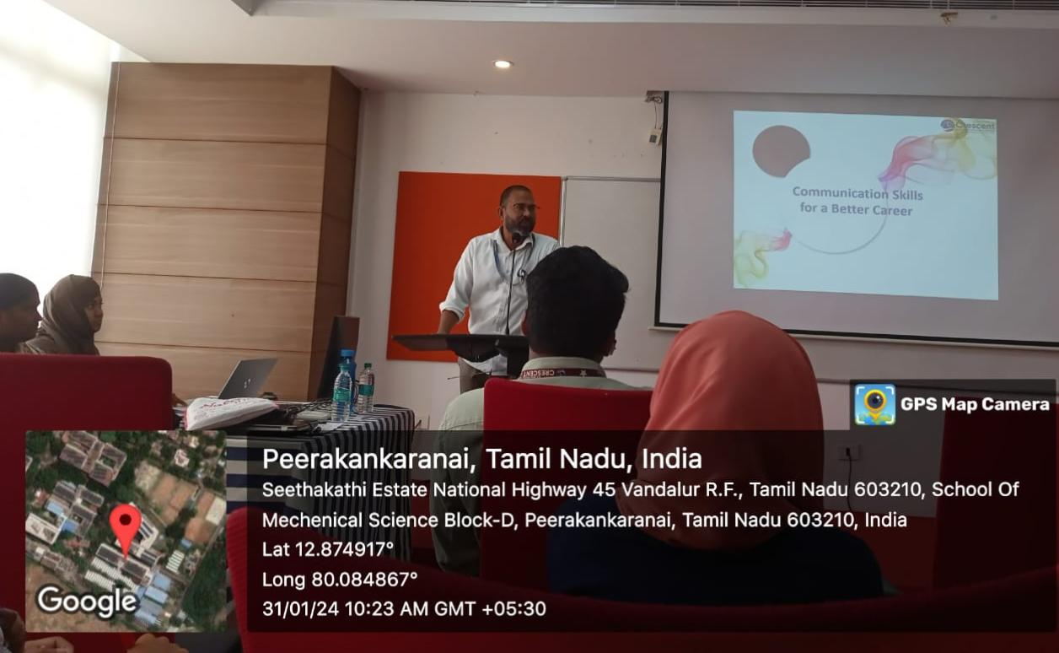

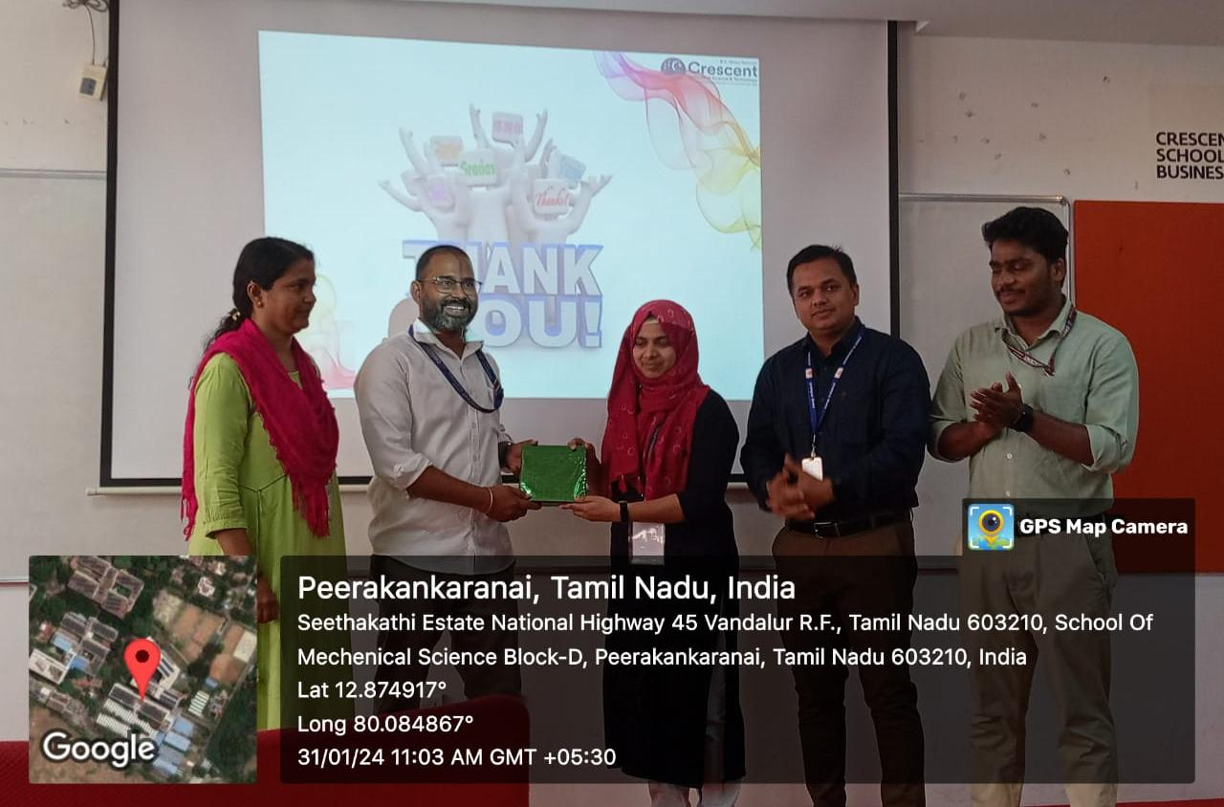

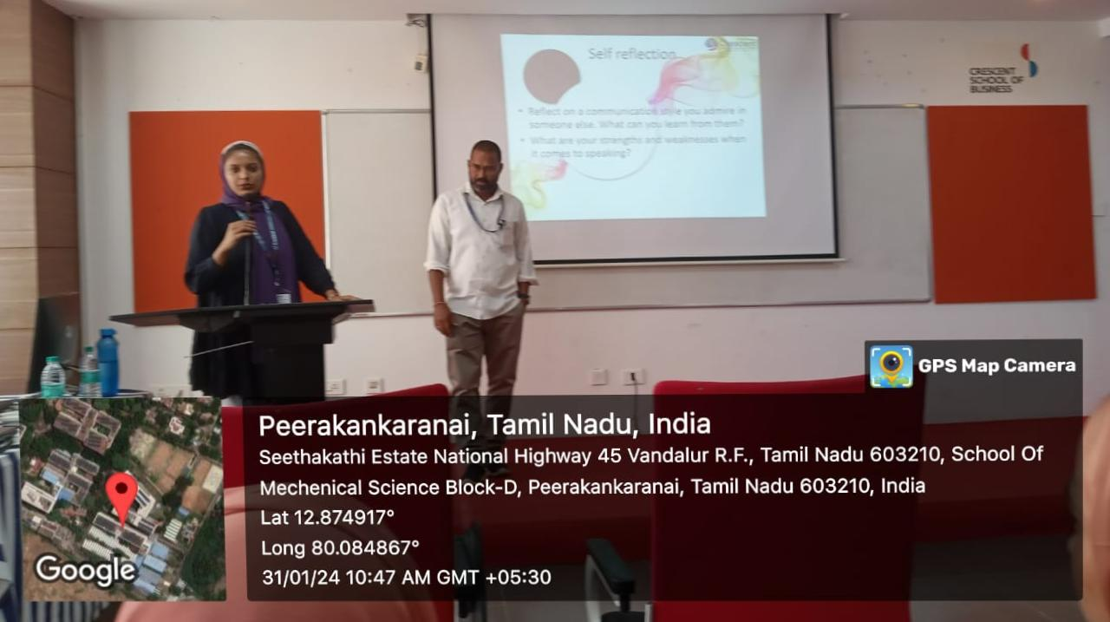

# **Session 3**

In Session 2, from 11:00 am to 12:30 pm, a noteworthy International Guest Lecture took place on the topic

“ **Circular Economy Towards Sustainable Financial Development**“ Professor Dr. Tasya Aspiranti, Vice Dean for Academic Affairs at the Faculty of Economics and Business, Universitas Islam Bandung, Indonesia,

Led the session. This collaboration with the Department of Commerce BSACIST was initiated and welcomed by Bagya, with Dr. K. Soundarapandiyan, an Associated Professor in the Department of Commerce, felicitating the occasion.

She delved into the pressing global crises, particularly those faced by Asian countries. She outlined the potential solutions through the implementation of a circular economy, emphasizing its fundamental principles and drawing distinctions from a linear economy. The session also spotlighted the crucial role of banks in fostering a circular economy for societal betterment.

During the engaging presentation, students had the opportunity to pose questions, with Fitha and Rasha Nasir contributing inquiries that Dr. Tasya Aspiranti thoughtfully addressed. The session concluded with a vote of thanks delivered by Ashwin, expressing gratitude for the insightful lecture and interactive discussion.

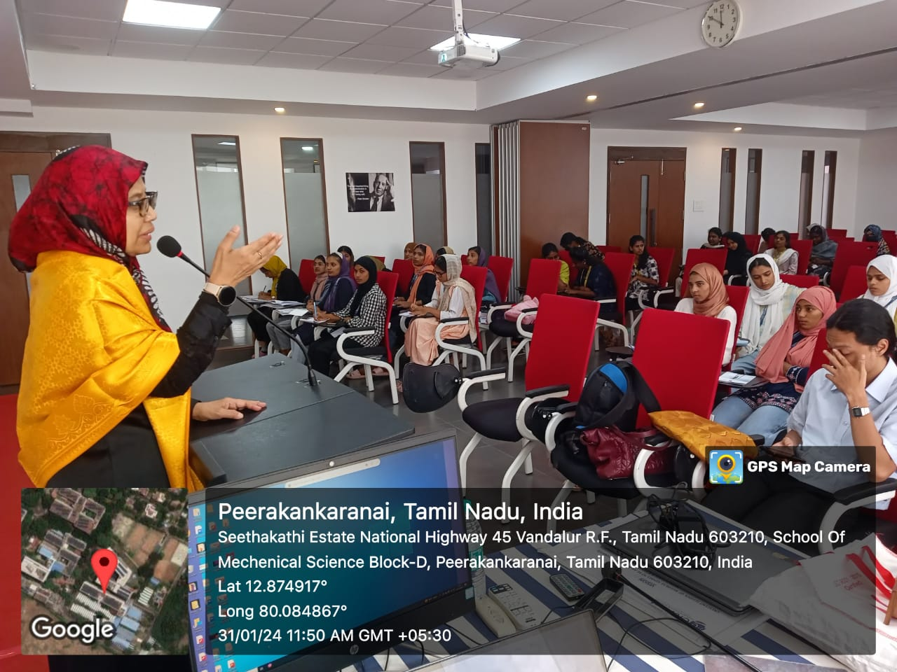

•Time:01.00pm-02.00pm

( Lunch Break)

# **Session 4**

Time : 2:00 pm – 4:00 pm

# **Topic :**

**Leadership**

Faculty :

_Prof. S. Sadhish Prabhu (Assistant professor, Department of Electronics and Communication Engineering, BSACSIT)_

The third session clocked between 2:00-4:00 pm the esteemed Assistant Professor of the Department of Electronics and Communication Engineering at BSACSIT, Prof. S. Sadhish Prabhu, orchestrated an engaging exploration into the realm of Leadership. The participants were divided into 3 groups, each entrusted with a leader wielding unique, undisclosed directives.

The challenge at hand was to craft the tallest paper tower conceivable from limited resources. As the groups immersed themselves in this task, each leader covertly navigated their chosen leadership style: Autocratic, Democratic, and Laissez-faire.

This immersive session was a masterclass in decoding the intricate dance between leadership styles and their profound impact on group dynamics.

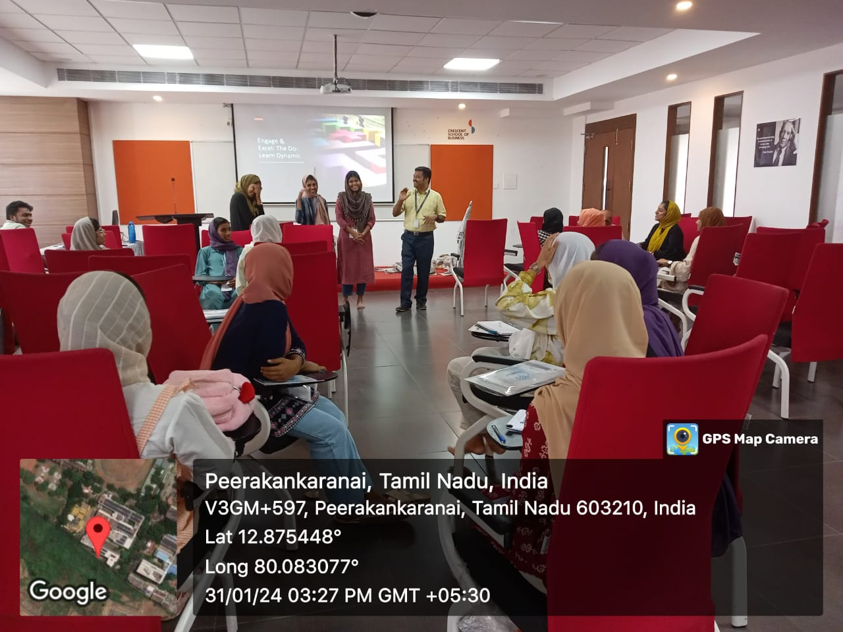

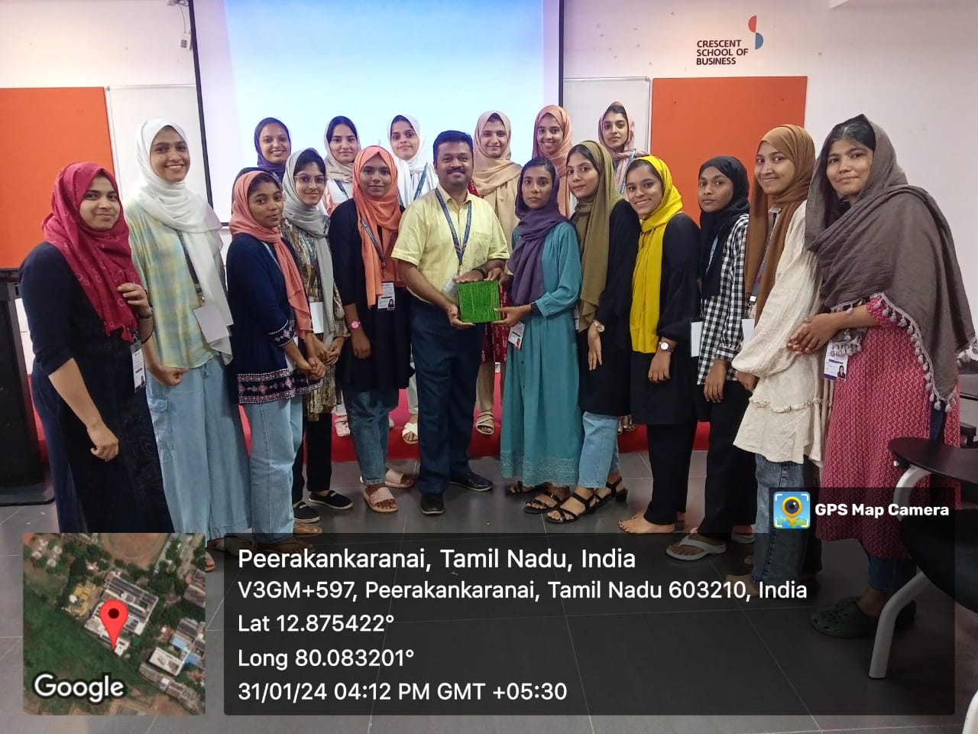

# **DAY 3**

01/02/2024

• Time :09.00am -01.00pm

• **Industrial Visit to Aavin, Solinganallur, Chennai**

**SHOLINGANALLUR DAIRY**

This Dairy is located at Sholinganallur on Old Mamallapuram Road (Rajiv Gandhi Salai).

Sholinganallur Dairy was established during the year 1994 under apex body of TCMPF Ltd., with milk processing capacity of 4 lakh liters per day to cater the South Chennai consumers.

This is South-East Asia’s first process Automated Dairy.The technology uses PLC (Programmable Logic Controller) and provided with SCADA (Supervisory Control and Data Acquisition) system.The automation system has been provided with hot standby PLC which takes over the control if the primary fails. As the process is fully automated the CIP (Cleaning In Place) process is very effective, resulting in consistency of finished product quality. This Dairy is certified with ISO – 22000-2005.

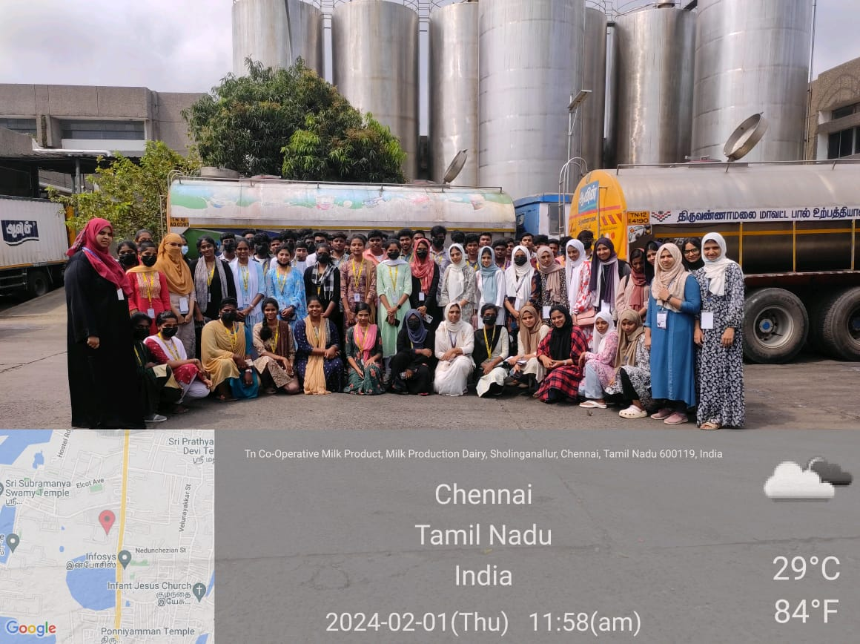

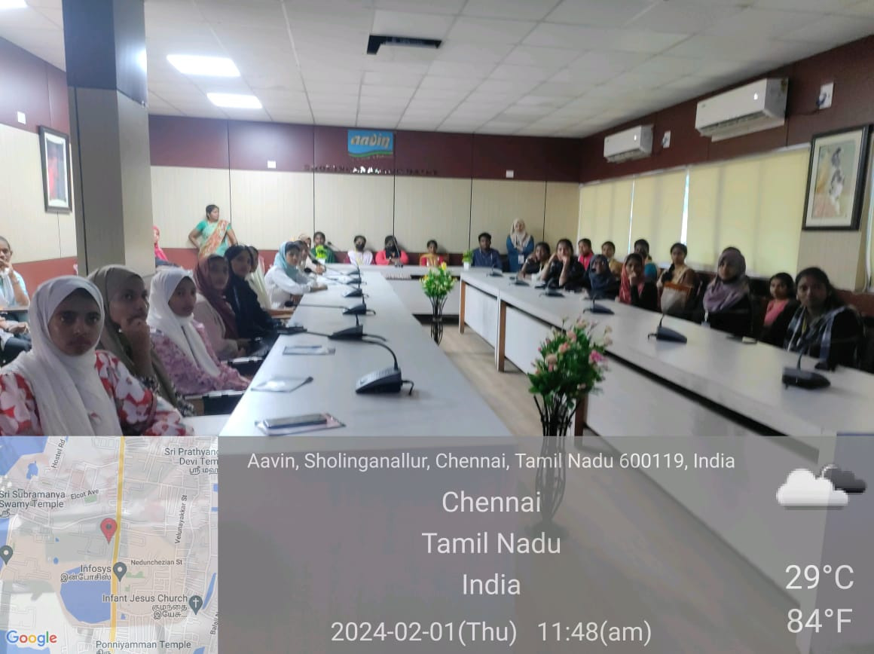

•Time:01.00pm-02.00pm

( Lunch Break)

# **Session 5**

Time : 02.00pm-04.00pm

**Lecture Report** :

_Artificial Intelligence by Dr. Aisha Banu W, Professor, and HOD , Department of CSE ,BSACIST_

The lecture on Artificial Intelligence delivered by Dr. Aisha Banu W, the distinguished Professor and Head of the CSE provided a comprehensive overview of the current landscape and future prospects of AI. This report summarizes the key insights and highlights from the enlightening session.

**1.Foundations of AI:**

Dr. Aisha began by introducing the operational systems of students phones elucidating the foundational concepts of AI, covering its historical evolution, core principles, and the interdisciplinary nature of the field.

**2 .Machine Learning Paradigms:**

The lecture extensively covered various machine learning paradigms, including supervised learning, unsupervised learning, and reinforcement learning. Practical examples and case studies were shared to illustrate their applications.

**3. Ethical Considerations:**

An essential aspect of the lecture was the discussion on ethical considerations in AI. Dr. Aisha emphasized the importance of responsible AI development, addressing biases, and ensuring transparency in algorithms.

**4. Emerging Technologies:**

The lecture delved into emerging technologies within the AI domain, such as natural language processing, computer vision, and robotics. Recent advancements and their impact on industries were explored.

**5. Challenges and Future Directions:**

Dr. Aisha candidly addressed the challenges faced by the AI community, including ethical dilemmas, data privacy issues, and the need for continuous research.

She also made us all aware about the deep fake issues that’s getting common.

Future directions and potential breakthroughs were also highlighted.

**Interactive Session:**

A significant portion of the lecture involved an interactive session where attendees had the opportunity to engage with Dr. Aisha, asking questions and participating in discussions. This fostered a dynamic learning environment and provided valuable insights.

**Conclusion**:

Dr. Aisha Banu W’s lecture on Artificial Intelligence not only provided a solid understanding of the foundational principles but also explored the ethical dimensions and emerging trends in the field. The interactive session facilitated a deeper engagement with the subject, making the lecture a well-rounded and insightful experience for all participants.

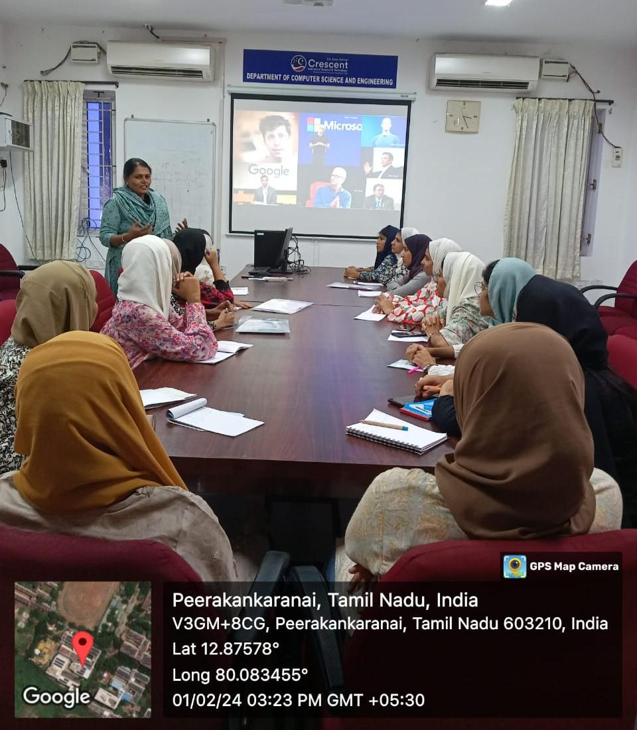

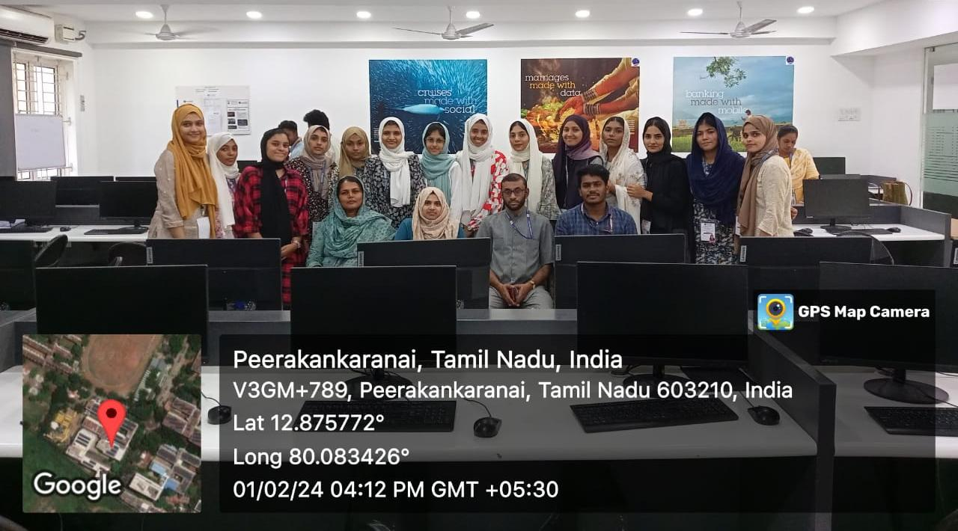

# **DAY 4**

02/02/2024

# **Session 6**

• Time :10:00 to 12:00 pm

Topic :

**Career Guidance in Civil Service**

Resource person :

Mr. Ilanchezhian,

_Program Director of the Department of Public Policy at BSACIST_

A captivating guest lecture on ‘Career Guidance in Civil Service’ was presented by Mr. Ilanchezhian, the Program Director of the Department of Public Policy at BSACIST. The event was initiated and warmly welcomed by Nisamudheen.

Mr. K Ilanchezhian commenced the session by discussing various types of competitive exams and offering valuable insights on how to excel in exams like UPSC, NET, SSC, etc. He provided a detailed overview of the UPSC syllabus and shared effective strategies for success. The session concluded with a powerful message from Mr. Ilanchezhian: “Never limit your dreams.”

The interactive nature of the session allowed students to actively participate and ask questions. Notable queries were posed by Basila, Zuhra Fathima, and Amna, enhancing the overall engagement and enriching the learning experience. Fathima Zuhra concluded the session with a vote of thanks, expressing gratitude for the insightful lecture and the interactive discussion that ensued.

This session not only imparted valuable information but also inspired students to reach beyond their limits in the pursuit of a career in civil service.

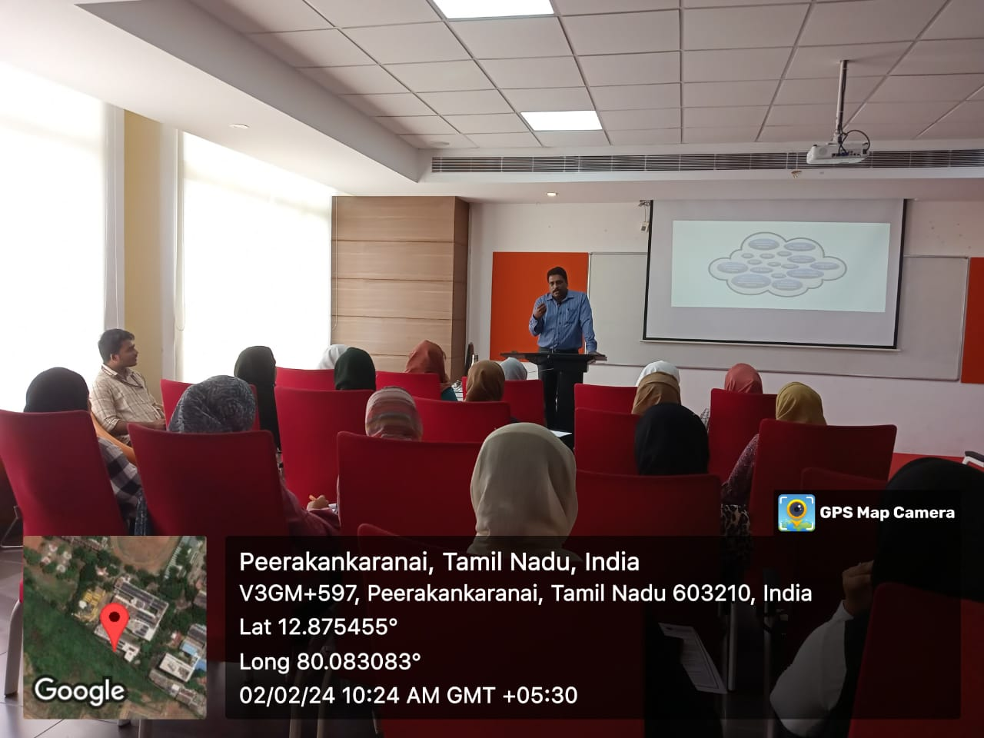

# **Session 7**

( Rescheduled)

Time : 12.00pm-01.00pm

Topic :

**Introducing MBA – IEV (Innovation, Entrepreneurship and Venture Development**)

Resource Person:

_Dr. G Kalyanaraman (_ _Assistant professor for Department of Management Studies, BSACIST )._

The session started with the resource person inquiring about the students’ disciplines. The focal point of the discussion was the unique MBA – IEV program at BSACIST, intricately designed around the startup ecosystem, emphasizing Innovation and Growth as the foundational pillars for enterprises. The speaker shared valuable personal experiences in entrepreneurship, creating an engaging and informative atmosphere. Following a Q&A session with the students, Ajnisha K C delivered a vote of thanks for the insightful session.

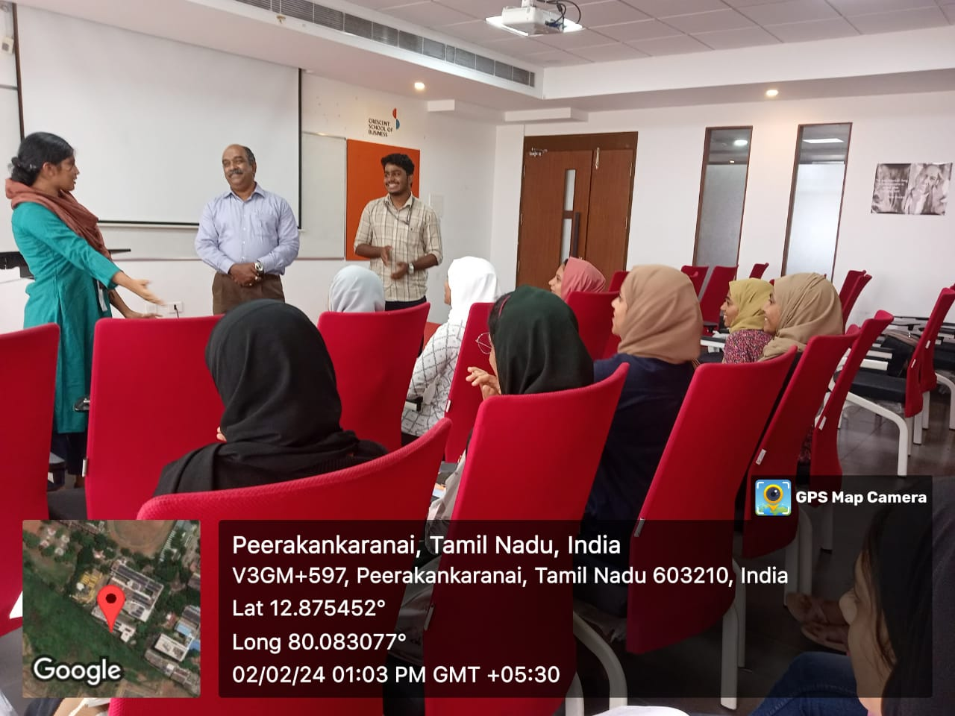

•Time:01.00pm-02.00pm

(Lunch Break)

# **Session 8**

Time: 02.00pm-03.00pm

Topic :

**Salient features of Indian Constitution**

Resource person:

_Dr. Chockalingam, Professor and Dean, Crescent School of Law,_ _BSACIST_

The session aimed to deepen participants understanding of the fundamental rights, preamble, and contemporary relevance of the Indian Constitution.

The session provided a comprehensive overview of the fundamental rights, preamble, and their contemporary significance within the framework of the Indian Constitution. By fostering critical thinking and dialogue, it empowered participants to navigate complex socio-legal challenges while upholding the core principles of democracy and justice.

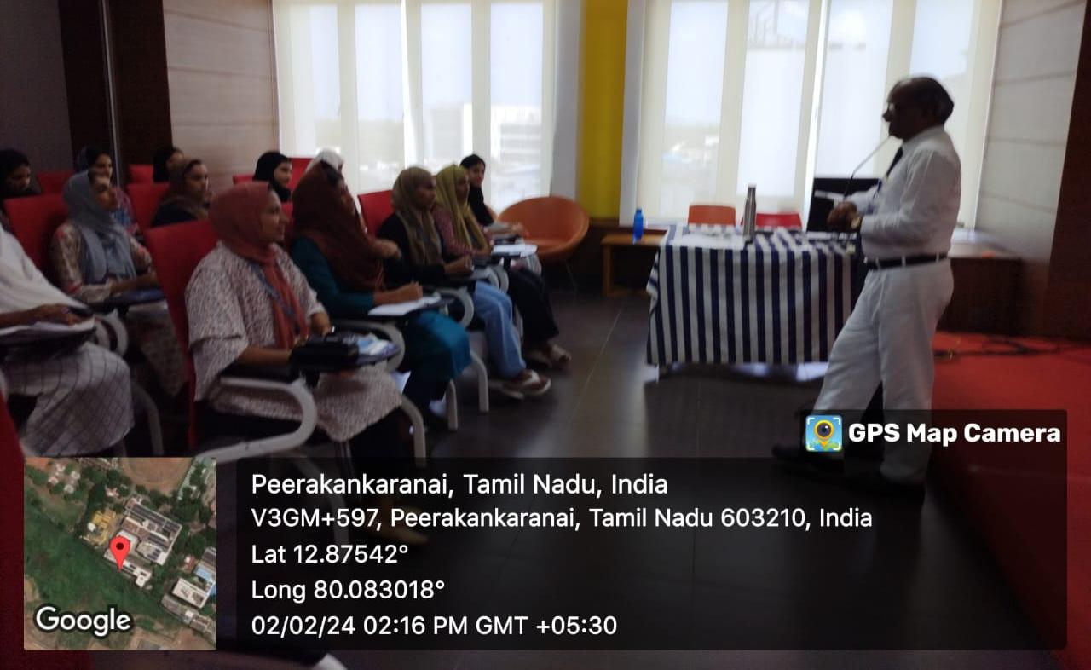

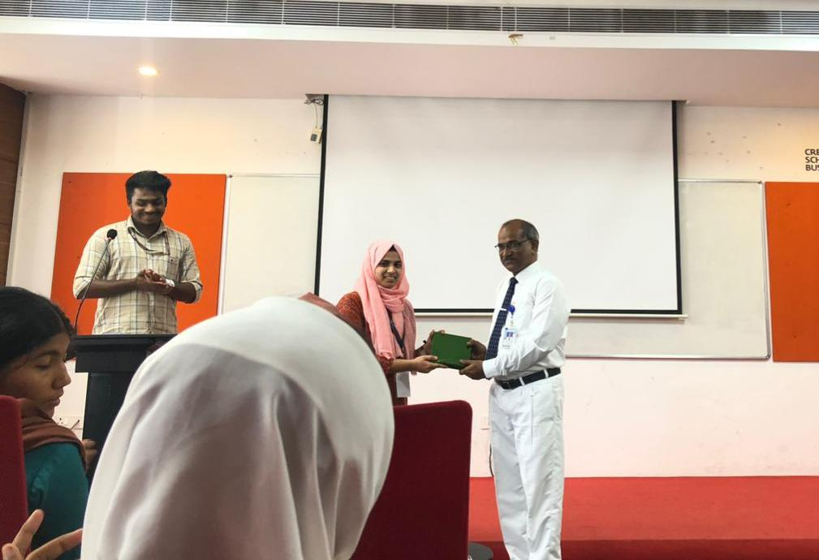

# **Session 9**

Time: 4:00 pm to 5:00

Topic:

**Women & Law**

Resource person :

_Dr. Vijayakshmi_

_Assistant Professor Department of Law at BSACIST_

In the informative session held from 4:00 pm to 5:00 pm, an impactful lecture was presented on the critical subject of “Women & Law.” Dr. Vijayakshmi, a distinguished Assistant Professor from the department of Law at BSACIST, orchestrated this profound session. The event was an initiative in collaboration with the Department of Law BSACIST, graciously introduced by Anjali, with Professor N. Murali, a prominent member of the Department of Law, warmly welcoming the participants.

Dr. Vijayakshmi delved into the complex interplay between women and the legal system, highlighting the historical strides and present challenges faced by women in the realm of law. She emphasized the progress towards gender equality and the enduring obstacles on the road to justice and fairness. The lecture adeptly covered the notable contributions of women in legal spheres and their resilience against prevailing adversities.

The session was notably interactive, with students eagerly engaging and presenting pertinent questions. Contributions from Kavya and Arjun stood out, prompting an extensive and informative discussion, expertly navigated by Dr. Vijayakshmi’s profound knowledge and experience. The session culminated with a vote of thanks from sir Nizamudheen, who eloquently expressed the collective gratitude for the enlightening lecture and the dynamic interaction that ensued.

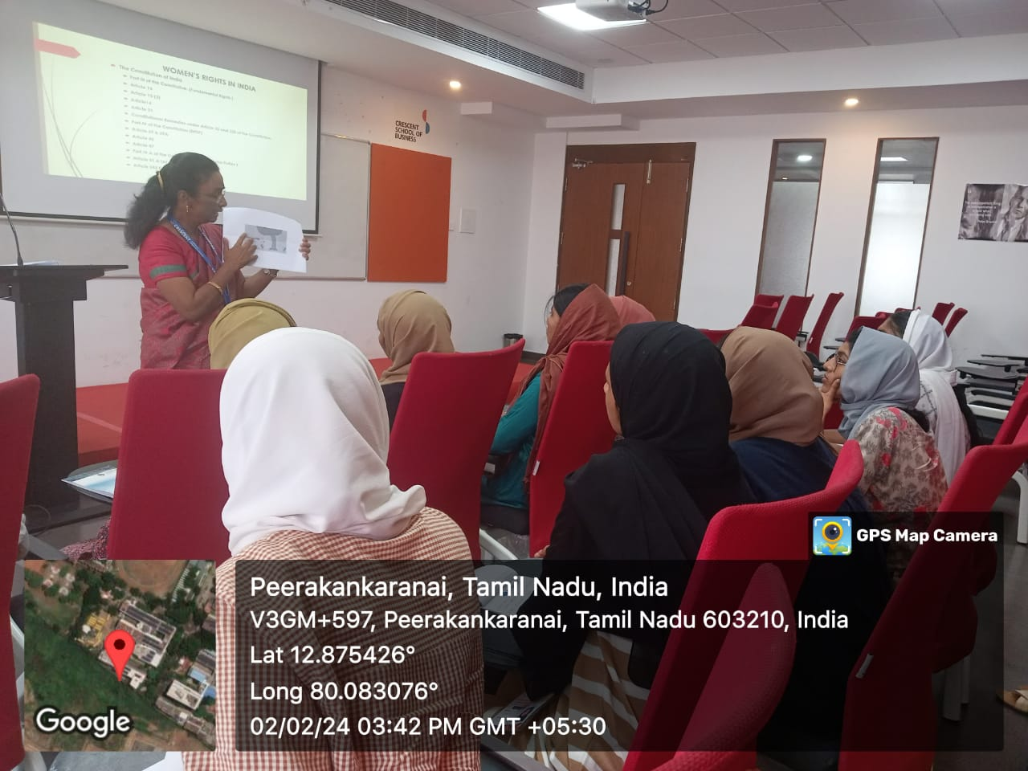

# **DAY 5**

03/02/2024

Time:10.00am -04.00pm

**•Visit to Mahabalipuram**

Mahabalipuram, a UNESCO World Heritage Site in Tamil Nadu, India, offers stunning rock-cut temples, sculptures, and coastal views. Highlights include the Shore Temple, Five Rathas, and Arjuna’s Penance, showcasing ancient Pallava architecture and craftsmanship. Visitors can enjoy beaches, seafood, and shopping, but crowds may detract from the serene ambiance.

Mahabalipuram is a captivating blend of history, spirituality, and natural beauty.

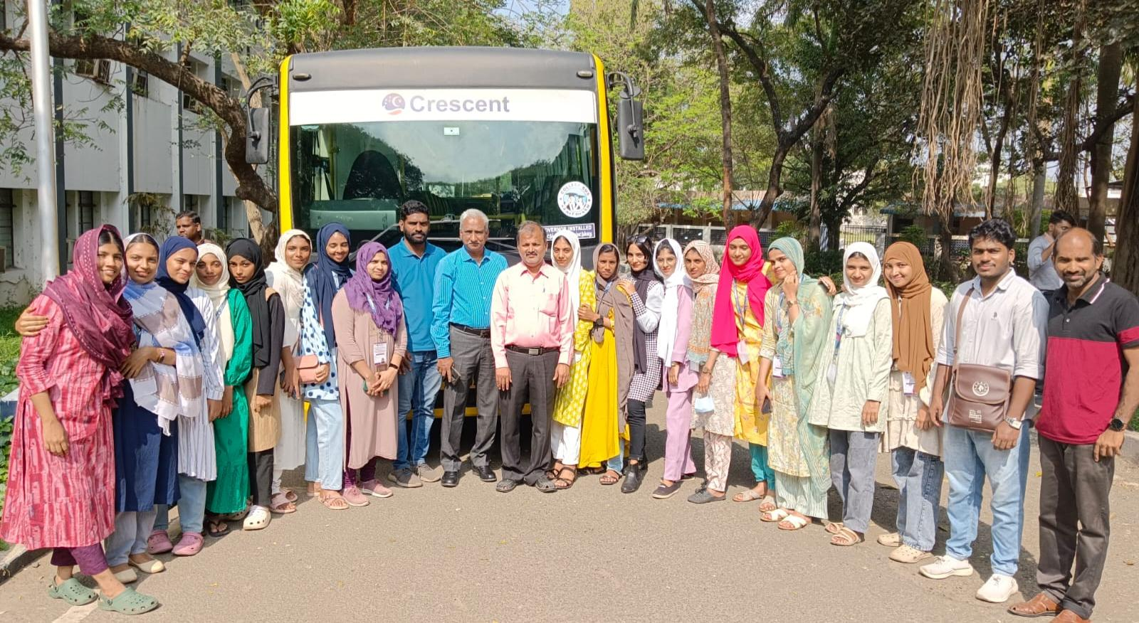

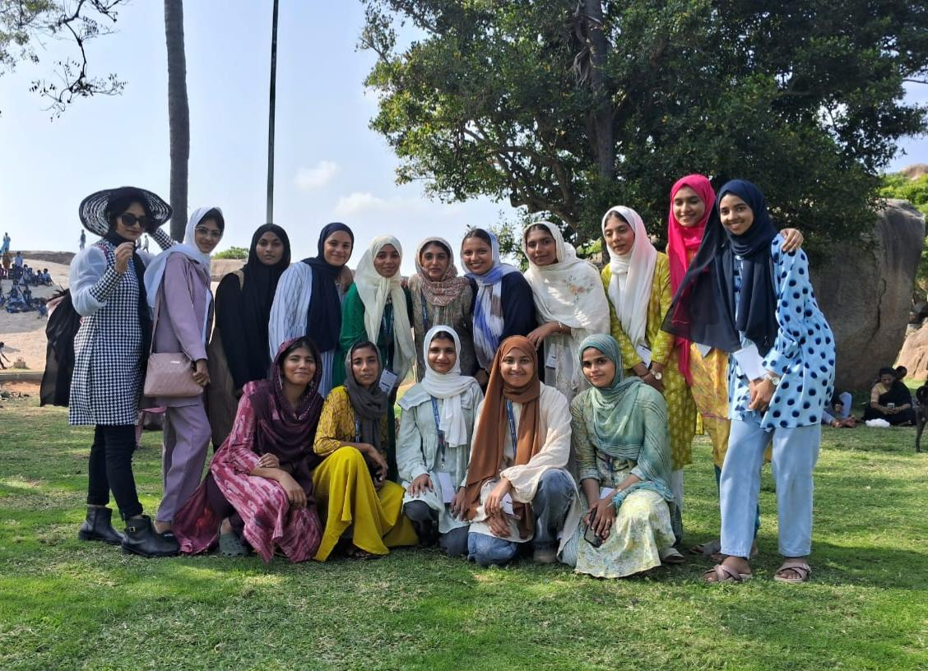

# **DAY 6**

05/02/2024

**```Valedictory Session```**

An esteemed gathering marked the culmination of an eventful session at Seminar Hall of BSACIST. The occasion witnessed the convergence of intellect, experience, and gratitude, as students and faculty members from Sullamussalam Science College gathered to extend their appreciation towards B. S Abdurahiman Crescent Institute of Science and Technology.

The event commenced with a warm welcome extended by Dr. K. Soundarapandiyan, Associate Professor & Head,Department of Commerce,setting a tone of inclusivity and warmth. His words resonated with a sense of belonging, embracing all participants into the fold of academic camaraderie.

Following the welcome, Mr. Ayub Khan Dawood,Professor and Dean, School of Social Sciences and Humanities, in his presidential address, articulated the essence of collaboration and shared academic endeavors, emphasizing the significance of fostering strong bonds within the academic community.

The inauguration ceremony, graced by Dr. A. K. Kaliluthin, Associate Professor in Civil Engineering & Deputy Director (Campus Development & Maintenance), marked a symbolic beginning, symbolizing growth and progress in academic infrastructure and development.

Dr. Krupa B. Nair, Assistant Professor (Sr. Gr.), was felicitated during the event, Her commendable efforts serve as an inspiration to all members of the academic fraternity.

The session also witnessed the presence of esteemed individuals, Nizamudheen and Younus Chengara, whose participation added depth and diversity to the discourse, enriching the collective experience of all attendees.

However, the highlight of the event was the valedictory session where students and faculties from Sullamussalam Science College expressed their heartfelt feedback and gratitude towards Crescent Institute. Their words reflected the profound impact of academic exchange and collaboration, emphasizing the transformative power of knowledge and mentorship.

In conclusion, the event served as a testament to the spirit of academia, fostering collaboration, appreciation, and growth. As the curtains draw close on this chapter, the echoes of gratitude and camaraderie linger, shaping the future of academic excellence and collective endeavor.

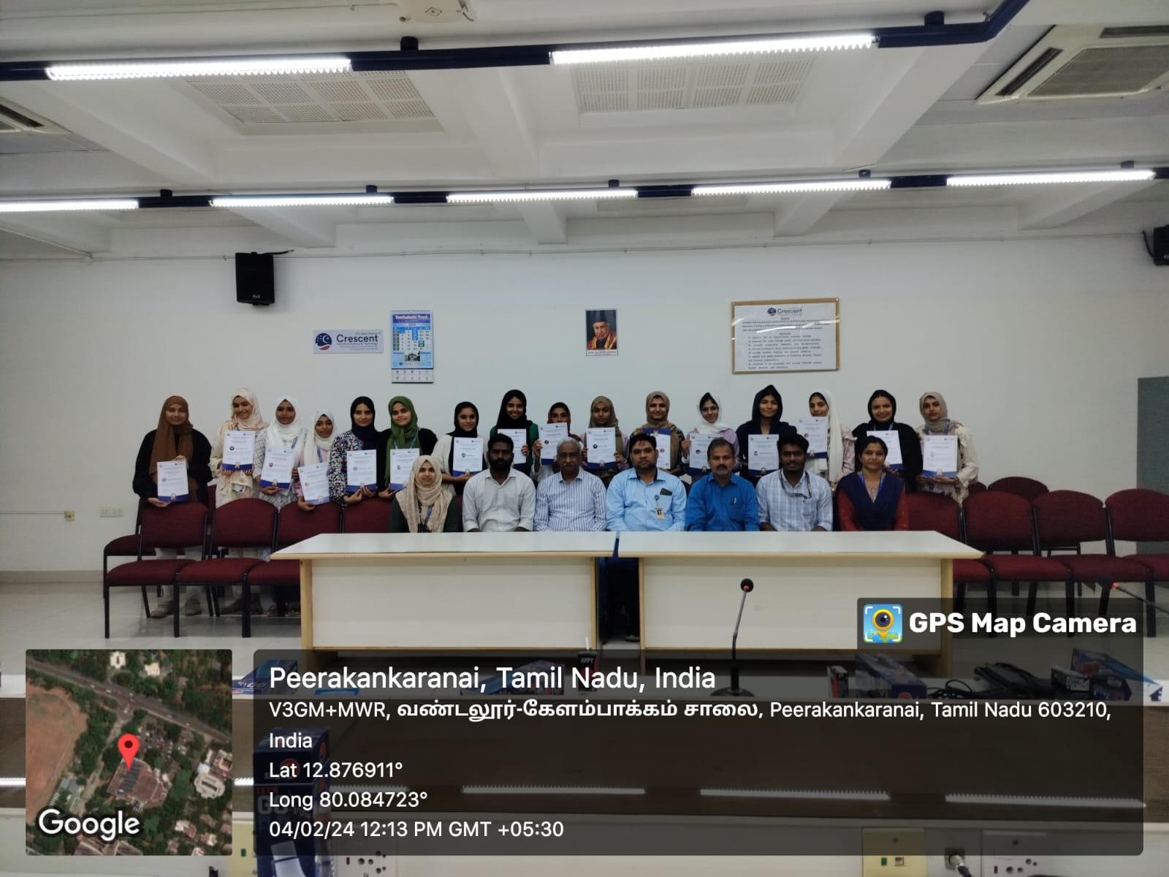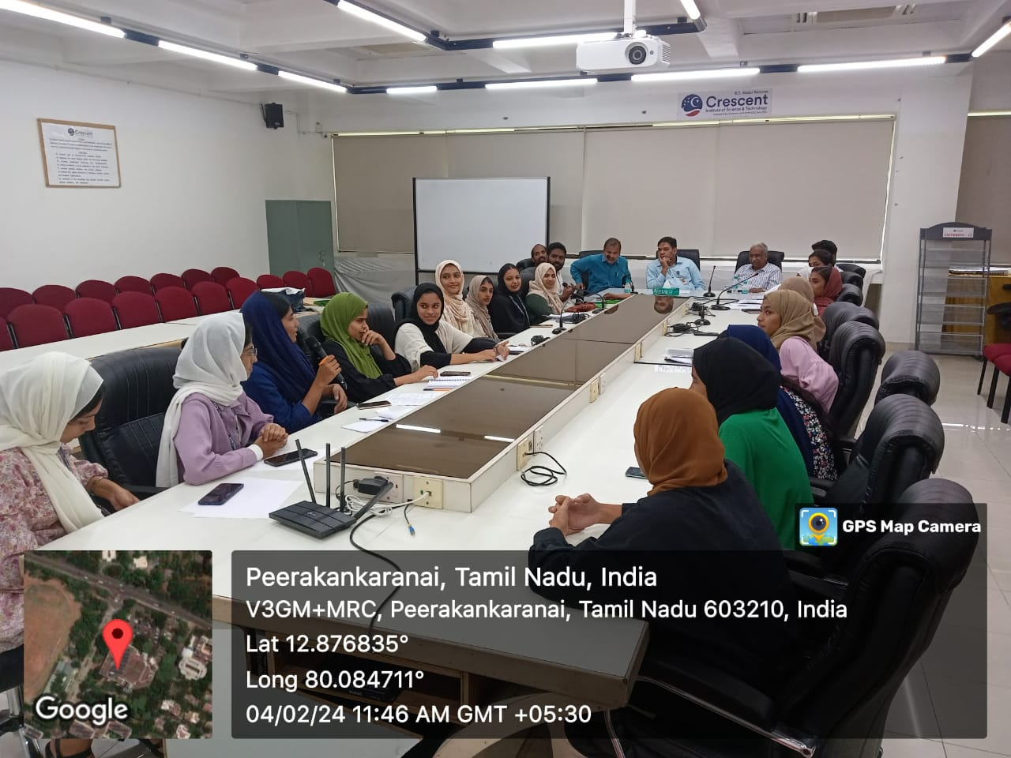

**Food**

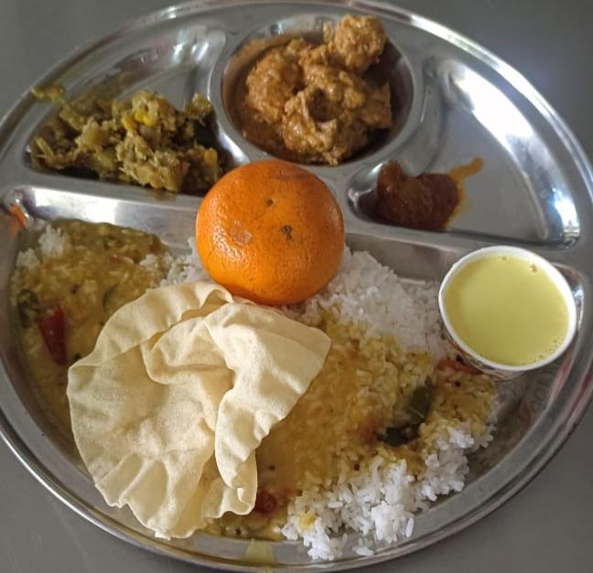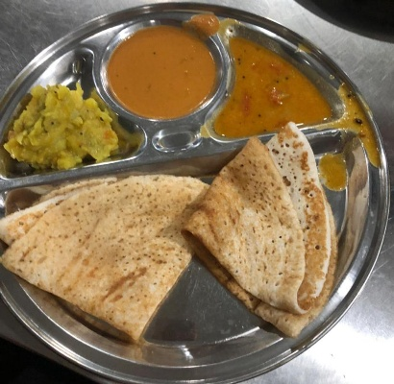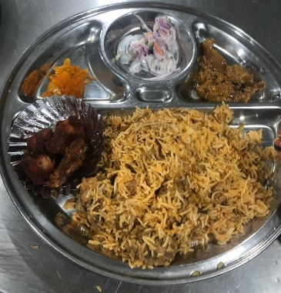

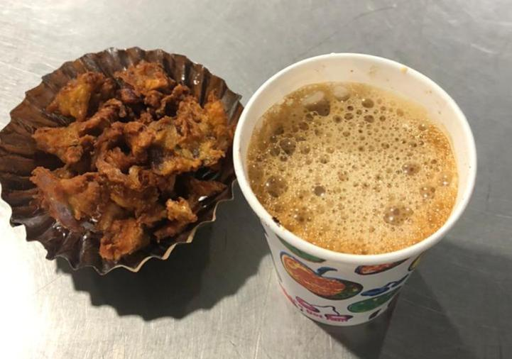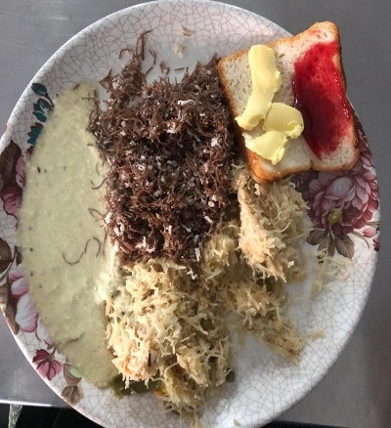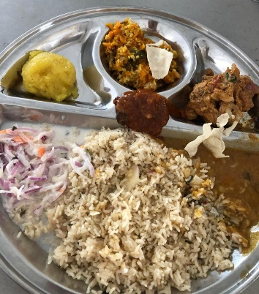

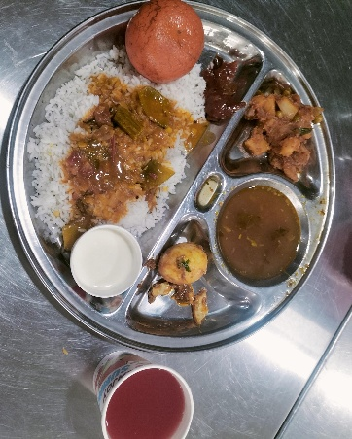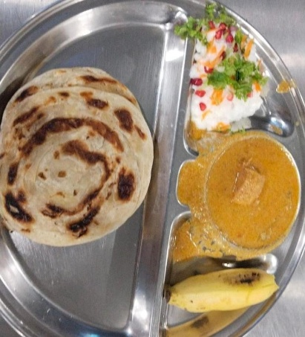

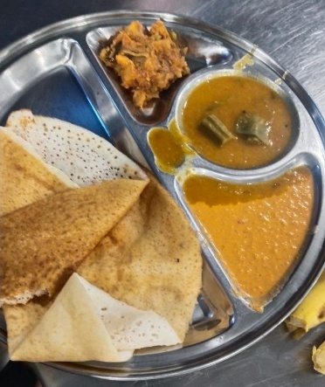

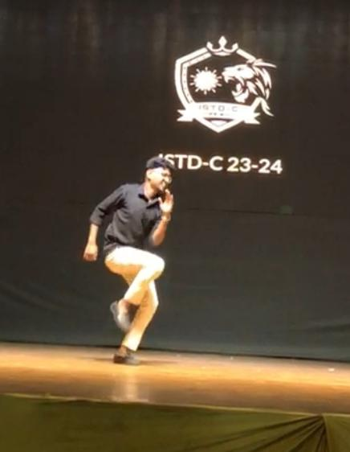**Cultural** 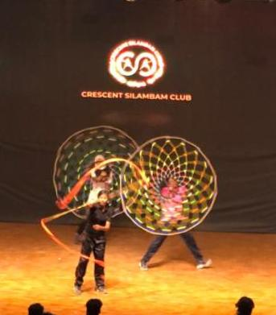

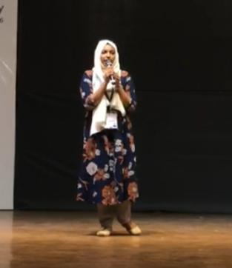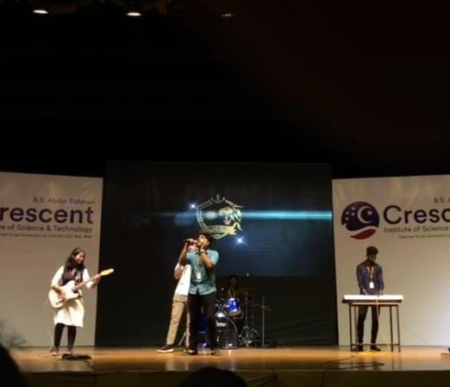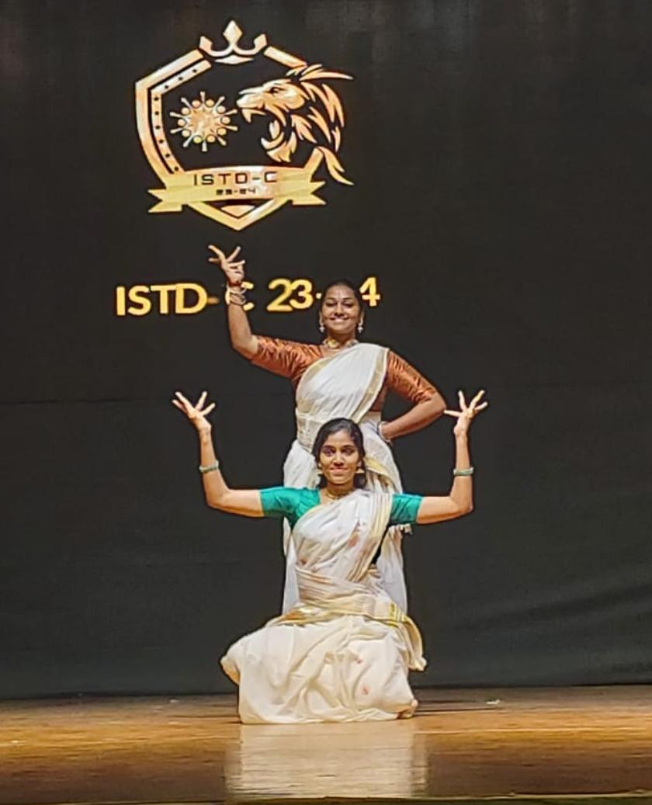

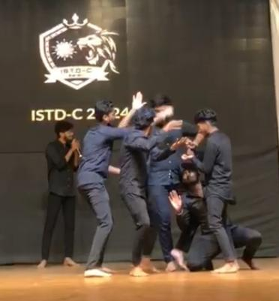

**Cresent**

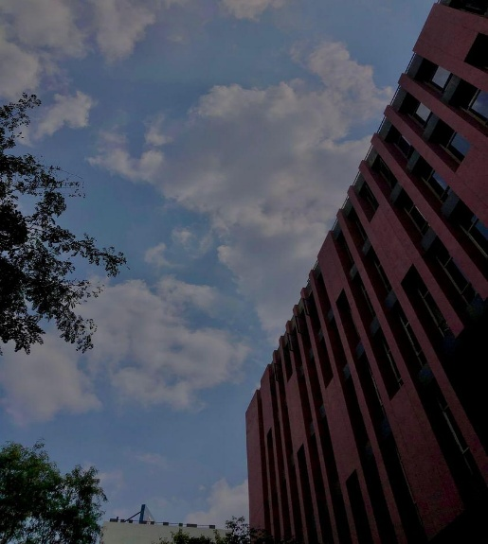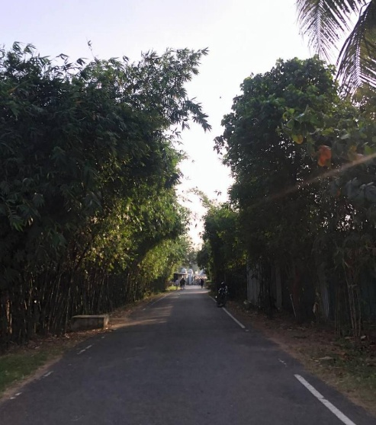

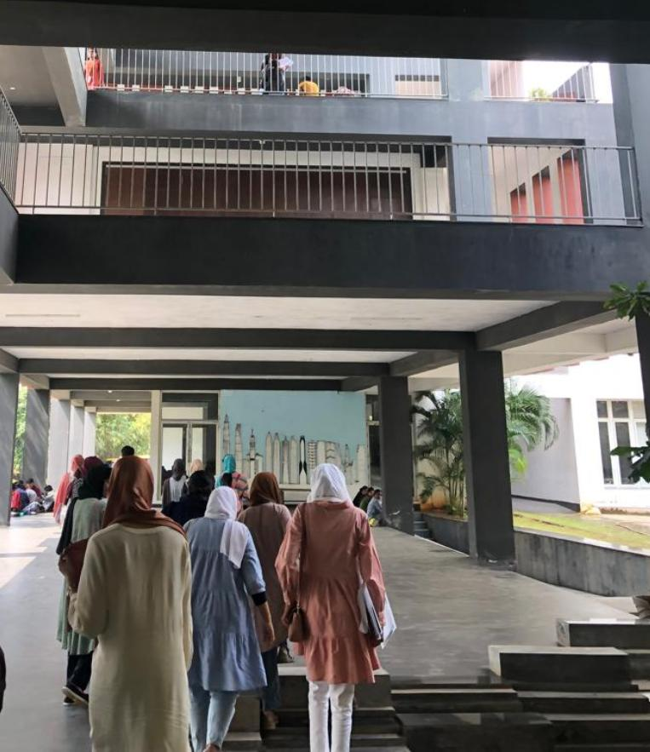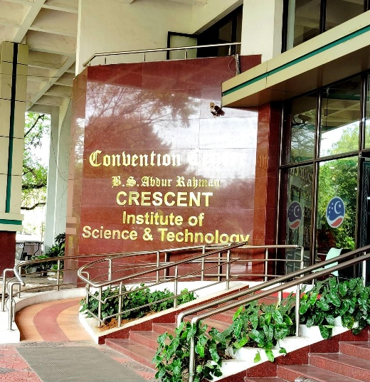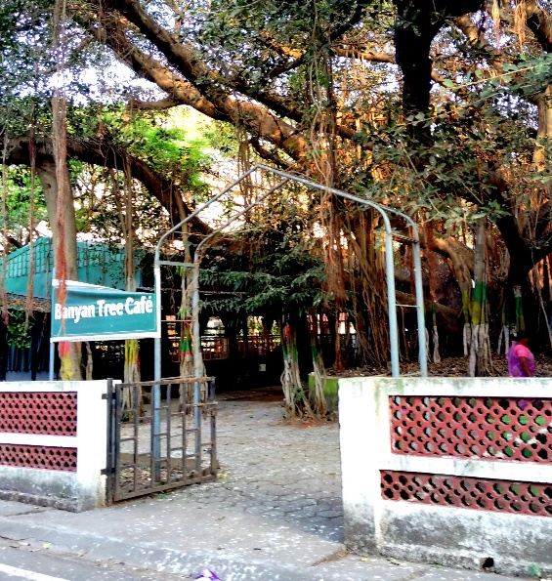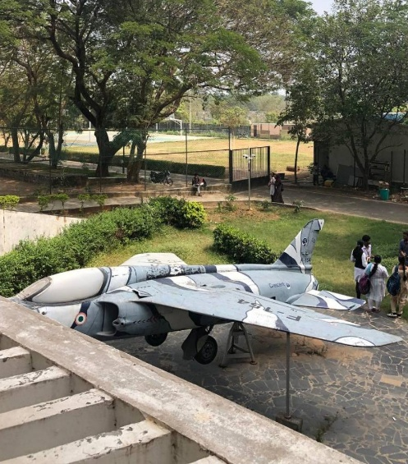

**Feedback**

* Those seven days were absolutely amazing! I felt so welcomed and included by everyone I met, and I learned so much, both academically and culturally. It’s an experience I’ll never forget.Thank you for this incredible opportunity which I will cherish forever.
* That program created a excellent school of thought in the mind of ours , we got to know a new campus, culture and people. More than i think it’s a journey of self discovery,we learned from each other’s cultures and formed a great relationship with all . Thankyou for this opportunity
* The SCILEX exchange program at Crescent University provided an exceptional seven-day experience. The faculty and students exhibited remarkable kindness throughout, facilitating an enriching learning environment. Beyond linguistic boundaries, I engaged in diverse educational opportunities that expanded my global perspective. I take great pride in being part of this program, recognizing its significant contribution to personal development and cultural understanding.Thank you for given this precious opportunity.
* The seven days I spent in Chennai for the student exchange program were absolutely amazing! From the moment I arrived, I felt incredibly welcomed and included by everyone I met. The warmth and hospitality made me feel right at home.

I had the opportunity to immerse myself in both academic and cultural experiences. The academic sessions were challenging and enlightening, and the interactive approach of the teachers helped me grasp new concepts quickly. Culturally, I enjoyed exploring the local cuisine, participating in traditional festivals, and visiting historical landmarks, which gave me a deeper appreciation of the local culture.Thank you for this opportunity, thanks a lot

* Cultural exchange program at Chennai Crescent University was a fantastic experience! It helped me challenge any preconceived notions I might have had and fostered a more open-minded perspective on Tamil culture. The program truly showcased the strength and resilience of the Tamil people. It was inspiring to learn about their rich heritage and cultural practices.
* My experience at BSA Crescent university was just seven days, But I felt like many months. This student exchange program thought me the value of academics and personality.The cultural immersion enriched my understanding of the world around me. Moreover, adapting to the Tamil culture teached me to embrace new experiences and overcome obstacles.

I’m truly grateful for the opportunity to interact with the senior faculties and the students of the university.And I’m sure those faces won’t fade away!

I think the confidence that I have right now is something that was created by the students of Crescent university by conducting the cultural programs.It was just unforgettable cherished moments with my beautiful ladies and i will carry those wonderful memories with me,until my last breath.

-The seven-day cultural student exchange program at BSA Crescent University was truly one of the most remarkable experiences I’ve ever had; it was utterly unforgettable. Each moment spent there became a cherished memory, and the knowledge gained during this trip has left an indelible mark on my being, transforming me in ways I never imagined. Every aspect of those seven days was filled with thoughtfulness and novelty, from the exquisite cuisine to the warmth of the people, from the breathtaking campus to the enlightening lessons it was all simply extraordinary. I am profoundly grateful for the opportunity to have been a part of this program.

- I feel very happy because I visited Chennai for the first time, and it was a wonderful experience. Through this exchange program, I learned about a new culture, including food, accommodation, and travel. The differences between Kerala and Tamil Nadu are fascinating. I felt like I joined a new family and learned how to balance academics and cultural programs. I also became more confident in facing an audience and overcoming my fear. I would like to thank you for giving me this opportunity.

- The student exchange program was an everlasting memory for me. Beyond the linguistic differences we shared a great time together.The faculty and students of the crescent university was very friendly and approachable. Through this programme i gained lots of knowledge. The academic sessions was very informative and relevant. The programme truly showcased the strength and resilience of the Tamil people.I enjoyed each moment at the campus and I wish to extend my heartfelt gratitude to all of you for providing this opportunity. Thank you so much

- The seven-day student exchange program at BSA Crescent University was a remarkable experience that I will always cherish. From the moment I arrived, I felt welcomed and included by everyone I met.

The academic sessions were highly engaging and expanded my knowledge. While the cultural activities, the local cuisine helped us to appreciate the beauty of Tamil culture much, much more.

I am sure this journey will be a important event in my life and in making me who I am. It expanded my perspectives, inspired me to realise I am capable of more than i imagined. Thank you.

* This student exchange programme gave me the most favorite and useful memories ever. More than memories the programme helped me to realize a new level of education sytsem just by spending one weak with BSA Crescent university chennai, which conducted the programme.and by watching the routine of the students made me realize that one need to be disciplined if he need a fluent life.
* But what truly stood out were the experiences. Whether it was interacting with current students, attending insightful lectures, or simply soaking in the campus vibe, every moment was memorable and impactful.
* 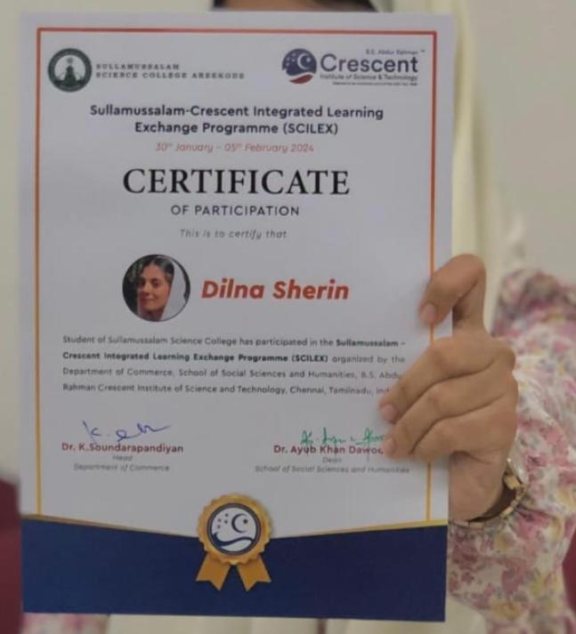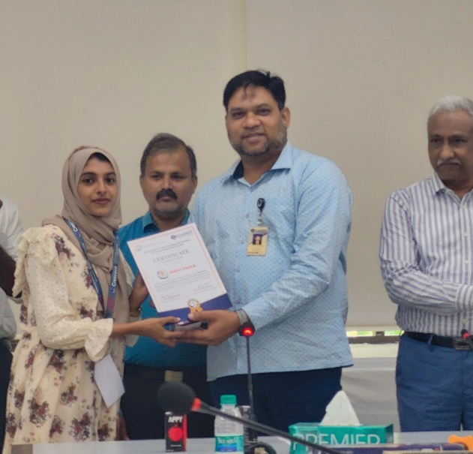In conclusion, my visit to BS Abdur Rahman Crescent University was nothing short of extraordinary. And i will carry those memories from the first day of boarding the train to the last day of departure forever. Thank you for conducting this programme and including me in this.Thank you

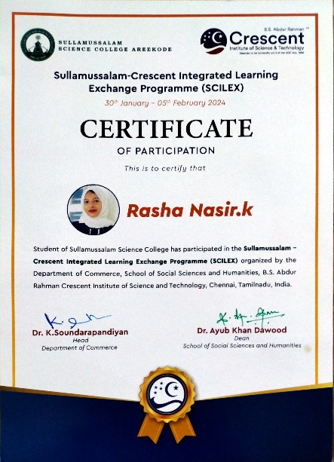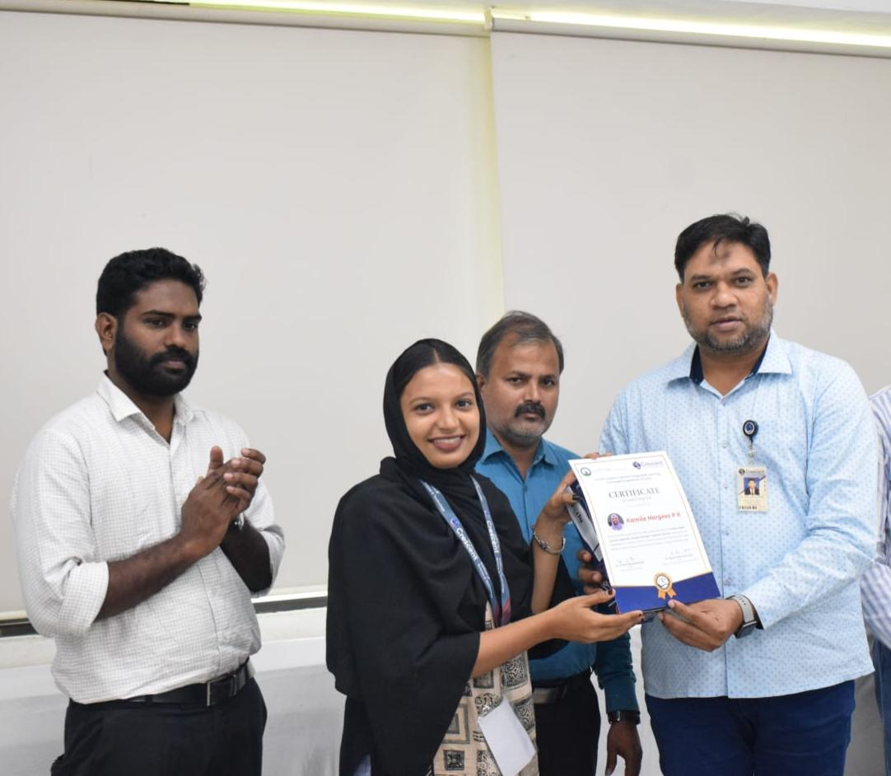

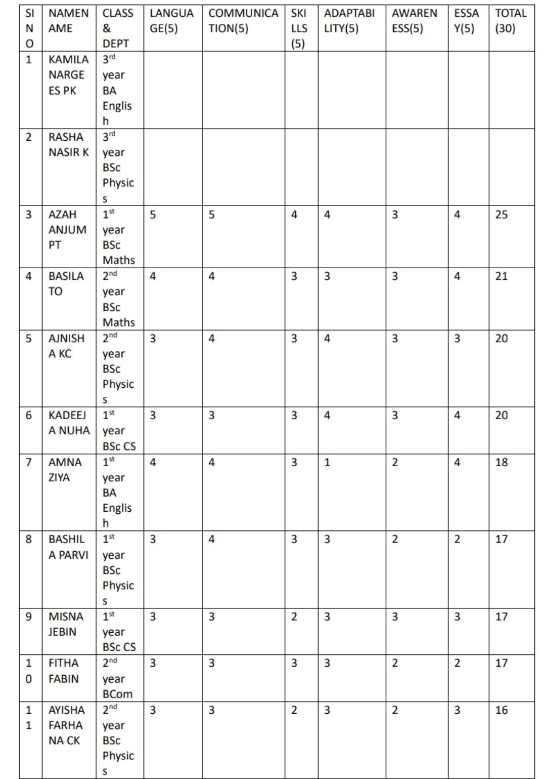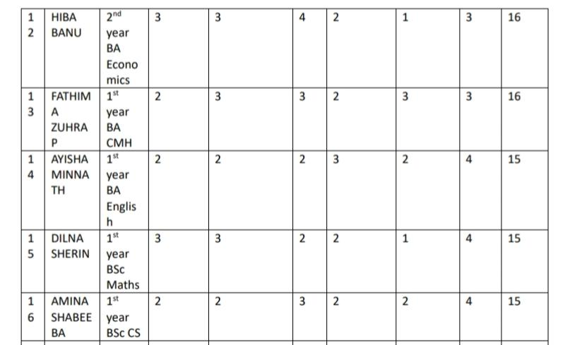

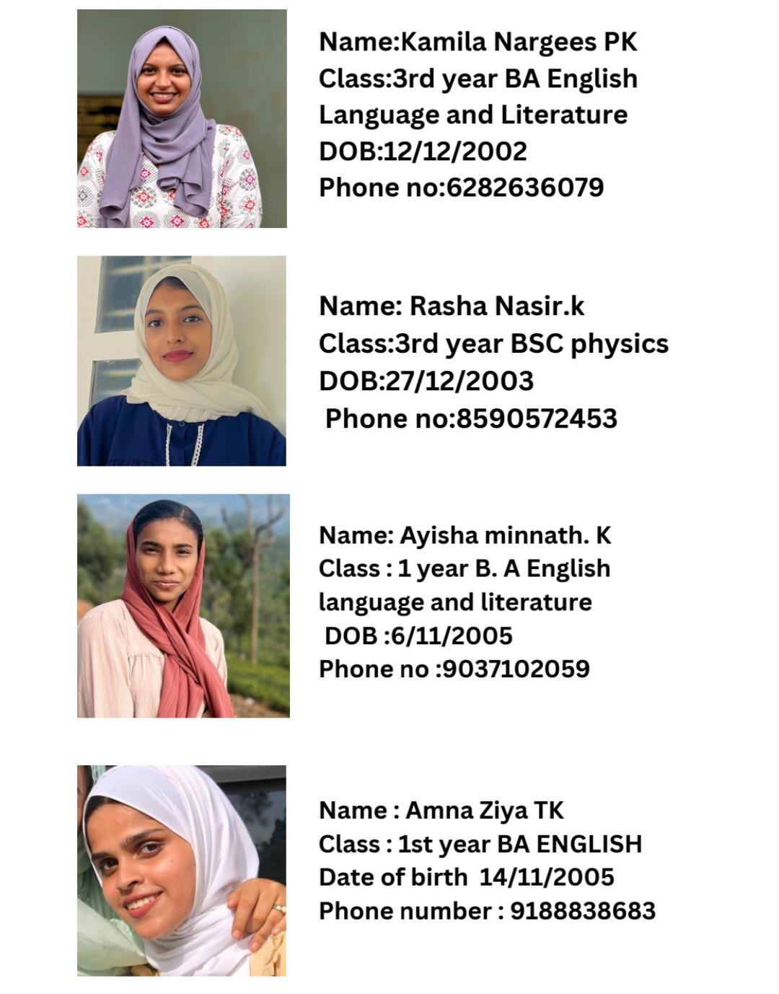

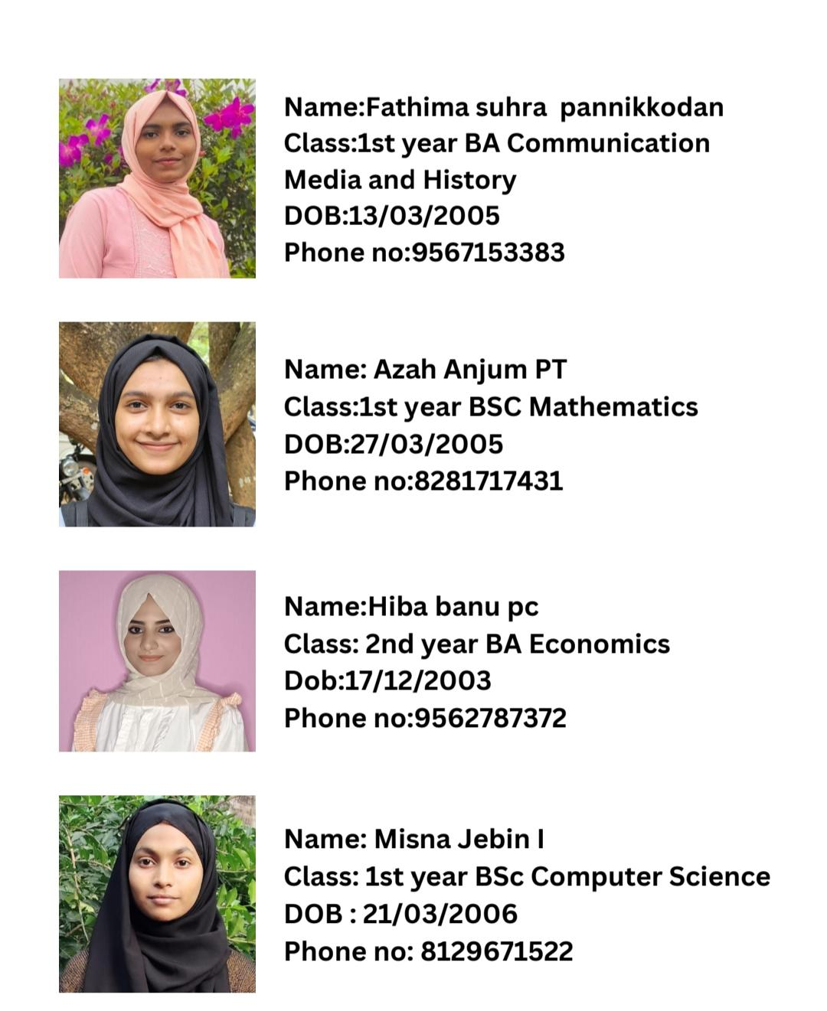

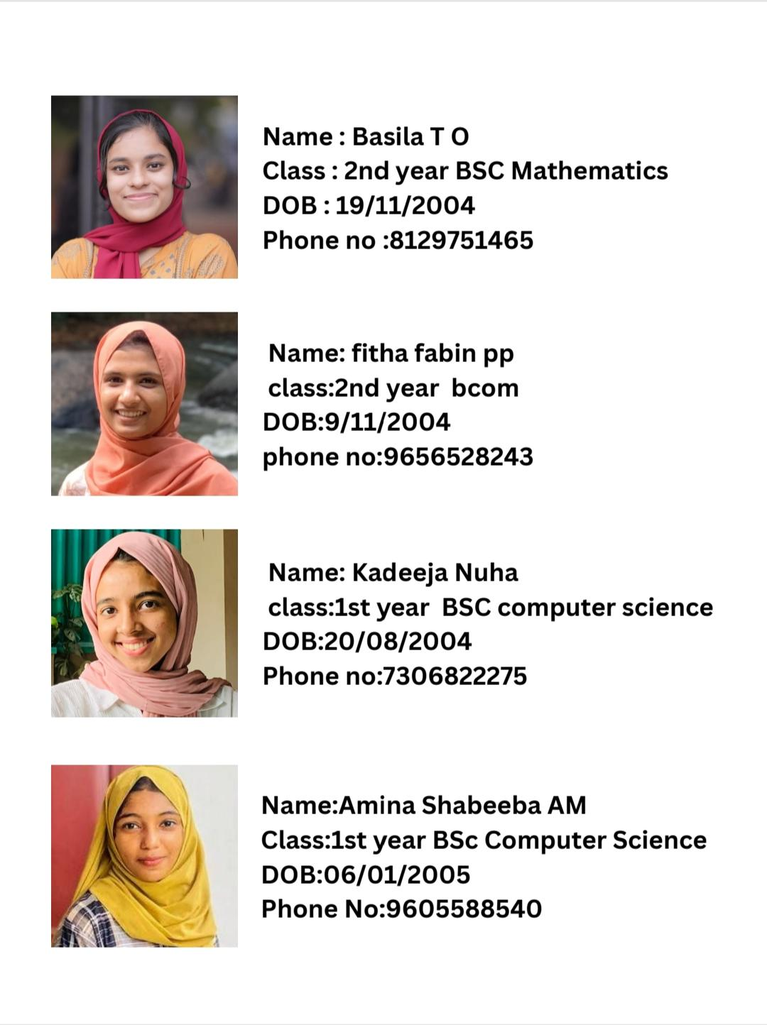

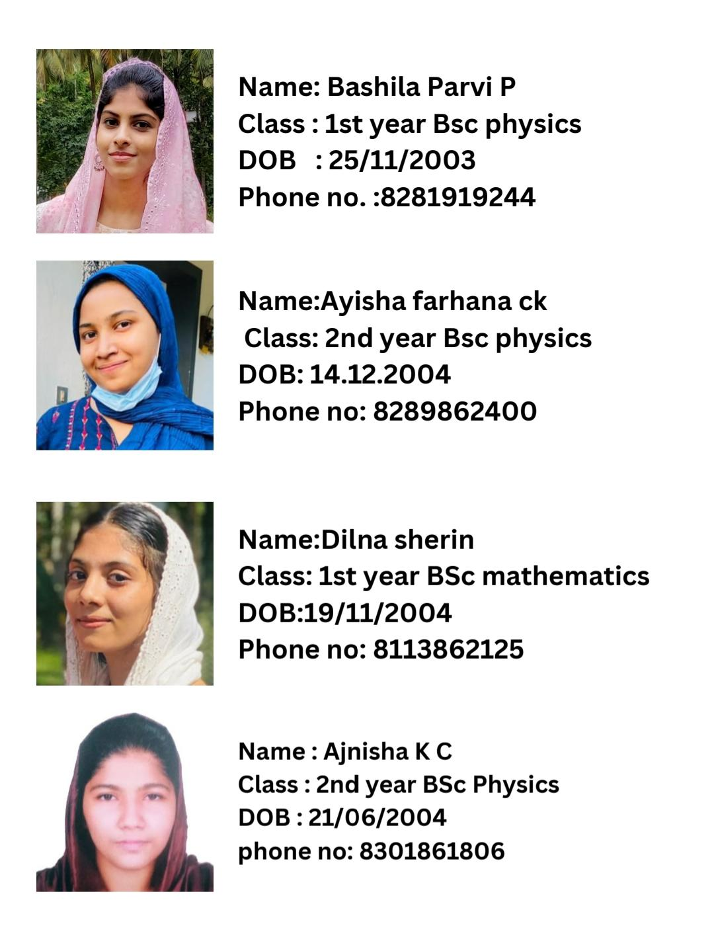

**Conclusion:**

As the SCILEX 2024 program came to an end,participants continue to embrace the opportunities for growth and collaboration that it offers. Through meaningful interactions, hands-on experiences, and cultural exchange, the program aims to empower participants to become well-rounded individuals equipped to tackle the challenges of the future.

PS:This report provides an overview of the Sullamussalam-Crescent Integrated Learning Exchange Programme (SCILEX) 2024 at BS Abdur Rahman Crescent Institute of Science and Technology, highlighting its objectives, outcomes, and the journey thus far.